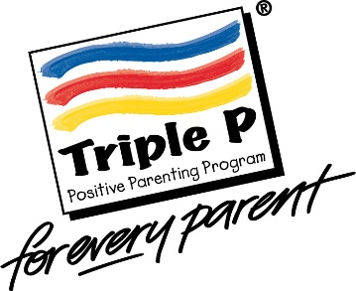
Triple P Group referral form

Date of Referral: Group location:

Parent/carers name/s:

Name of referrer & relationship to family:

Please note: A letter will be sent to parents/carers to confirm their place on the course, but it is the referrer’s responsibility to encourage attendance.

Child/young person’s name: Age:

Name/age of other children/young people in the household:

Please circle if the child/young person is subject to any of the following:

CP, CIN, CAF, ASSET, My Support Plan, EHCP, DART?

Name of any professional involved with child/family:

Does your child have a disability, additional needs or Special Educational Needs? Yes/No
If yes, please give brief details:

Armed Forces family? Yes/No

Attendee information (Who will attend the group & their relationship to child/young person):

Telephone number:

Address:

If a parent/carer has self-referred:

Please let us know if you have any additional requirements regarding access to the venue, British Sign Language, language interpreter or any dietary requirements.

Note to referrers and parents/carers
As facilitators’ we will make sure we are on time, supply refreshments and contact parents/carers by letter to confirm their place on the course. Unfortunately, we cannot provide childcare or transport.

Referrers: Please outline the following to parents/carers:
- That the group will close to parents after Session One and we cannot accept them on to the rest of the programme after that.
- That you support the parent to commit to attend every session – Triple P is a programme, not drop in sessions.
Parents/carers: Please try to be on time and let the facilitator know if you cannot attend a session. Unfortunately, we are unable to offer support with childcare and travel arrangements.

Please send this form to claire.turner@wiltshire.gov.uk
Thank you

