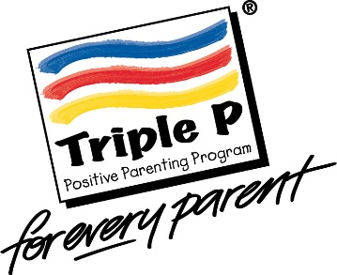
Triple P Group referral form

Date of referral: Group location:

Parent/carers name/s:

Name of referrer & relationship to family:

Please note: A letter or email will be sent to parents/carers to confirm their place on a course, but it is the referrer’s responsibility to encourage attendance.

Child or young person’s name and age:

Name and age of other children/young people in the household:

Please circle if the child/young person is subject to any of the following:

LAC, CP, CIN, CAF, ESA, My Support Plan, EHCP, DART?

Name of any professional involved with child/family:

Does your child have a disability, additional needs or Special Educational Needs? Yes/No
If yes, please give brief details:

Armed Forces family? Yes/No

Attendee information:
Name/s: Relationship to child/ren:

Phone number:

Email:

Address:

If a parent/carer has self-referred:
Please let us know if you have any additional requirements regarding access to the venue, British Sign Language, language interpreter or any dietary requirements.

I understand that this referral will involve Wiltshire Council holding information about me/us and my/our children and agree to this information being held on both paper and electronic systems.

Signed: Date:

Signed: Date:

Please return to parenting@wiltshire.gov.uk
Thank you

