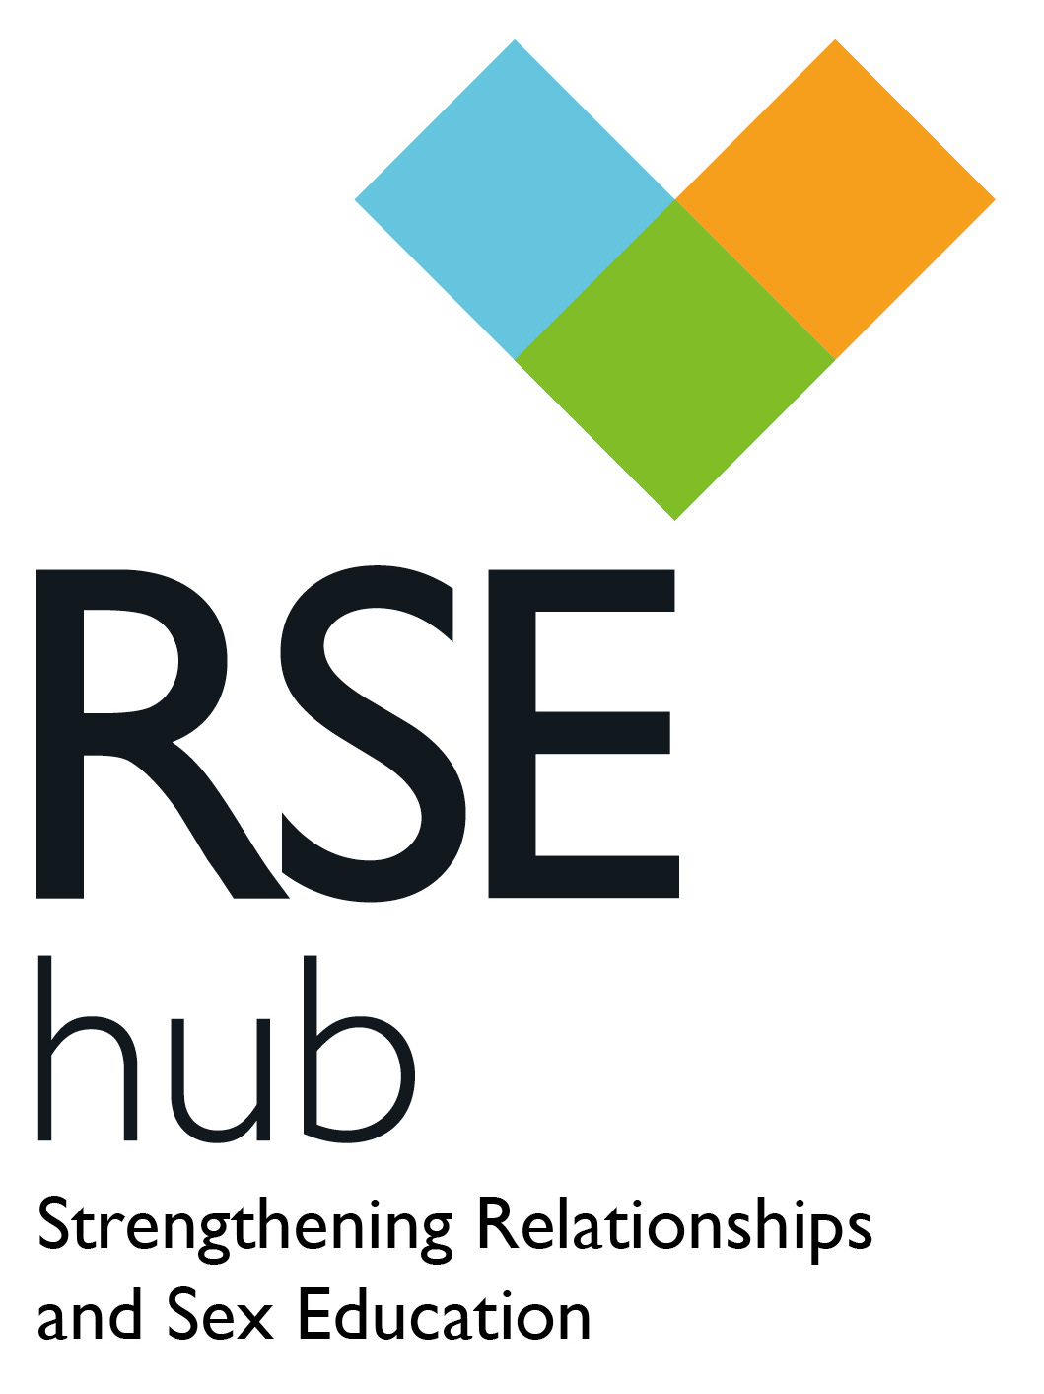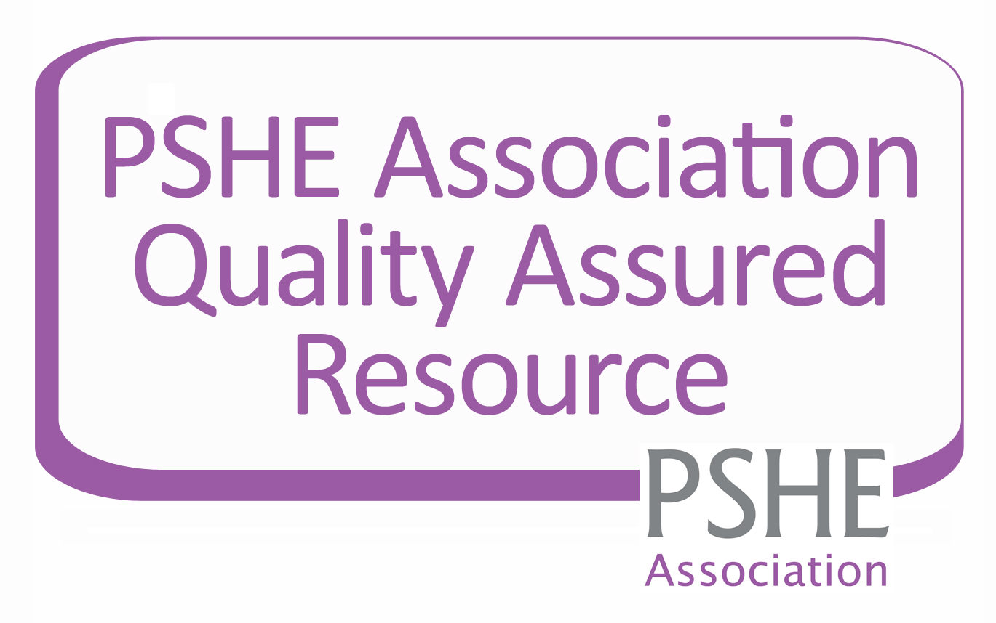

A Quality Review Framework for Relationships

and Sex Education in secondary settings

Secondary Review Framework for RSE



“I enjoyed it! A thoroughly enjoyable and useful experience.”

“It is always good to work with another school, observe similarities and differences and identify things to take away.”

“It provided a focused opportunity for collaboration between PSHE and Science”

“I thought it was excellent”

The RSE Hub is delivered in partnership with the social enterprise The Exchange Foundation and continues to be guided by an advisory group of statutory, non-statutory and independent specialists. The RSE Hub aims to provide relevant, credible and useful support for all aspects of Relationships and Sex Education.

This resource aims to help schools quality assure their RSE provision and create a development for sustained improvement as a whole school approach. This resource was developed following the pilot and evaluation of the In Depth Secondary Review Framework which was successfully piloted in schools in Wiltshire and Bath & North East Somerset, demonstrating that it provided an effective and comprehensive basis for schools to evaluate their own and each other’s RSE provision within a framework of mutual support. The evaluation identified the need to divide the criteria into core and quality to encourage accessibility and provide choice to schools with different requirements and levels of support. From this the Secondary Review Framework for RSE was developed.

Additional copies may be purchased from <http://www.rsehub.org.uk/>

For more information or support with the Quality Review Framework please contact info@rsehub.org.uk

Published by the RSE Hub

All rights reserved. The purchase of this document enables the staff within **one** school to use this document to quality assure their existing provision. Apart from reprographic reproduction of the tables for completion purposes this document may not be reproduced, altered, or transmitted in any form between schools without the written permission of the RSE Hub.

© The RSE Hub 2014

The Secondary Review Framework aims to enable schools, individually or in partnership, to undertake a review process at a level which seems manageable and appropriate to them. The review criteria are presented in two categories: **Core Criteria** and **Quality Criteria**, as defined below. This categorisation enables schools to focus their attention where their need is greatest, with the Core Criteria providing a minimum standard that all schools should expect to meet. This process can be carried out as either a self or a peer review.

Quality Criteria

Building on the core, these are the aspects of a developed RSE programme that add worth and value to young people’s learning experience and ensure it is related directly to their personal needs.

**Who is the Quality Review Framework useful for?**

* 11-18 educators of RSE
* Leaders of RSE within secondary school settings.
* Leaders of RSE that work with schools to improve RSE delivery

**Why complete the Quality Review Framework?**

Young people consistently say the RSE they receive is not good enough (SEF,2008) and Ofsted have repeatedly found RSE provision to be weak in many schools (Ofsted, 2002,2010,2013). The Quality Review Framework was developed in order that schools can review, develop and improve their RSE to ensure that the RSE they provide is of the highest standard, that meets national guidelines. This framework can be carried out as a peer or a self-review process.

Core Criteria

These are the fundamentals that underpin a secondary RSE programme – if any of these are lacking then urgent remedial action is required.

**What is the Quality Review Framework for RSE?**

The Quality Review Framework for RSE provides a set of materials, including detailed self-review criteria, which enable secondary schools to review and develop their Relationships and Sex Education (RSE) provision, to ensure that they are effectively meeting young people’s entitlement in this essential area of learning.

NOTES FOR GUIDANCE

NOTES FOR GUIDANCE

INTENDED OUTCOMES

For schools undertaking the peer review process, it is worth noting that the experience of the pilot schools was that they benefited greatly from the support of external consultants (whether Local Authority or independent) in planning and conducting the review. Whilst the framework is intended to support a genuine peer-to-peer review process, the ensuing logistical challenges can be enhanced by the involvement of external advisers or consultants. The RSE Hub can enable schools to access this kind of support at a level appropriate to their needs and resources.

**Intended Outcomes**

**Secondary Peer Review**

* Review and assess their own RSE provision with reference to a framework of criteria that are firmly grounded in current guidance and legislation
* Refine and authenticate their self-review through the evaluative judgements of colleagues from a partner school
* Widen their perspective on the planning and delivery of RSE by undertaking the same critical evaluation of provision in the partner school
* Benefit from a constructive and mutually supportive professional   
  dialogue with colleagues in a similar school setting
* Apply the findings of the review to formulate a development plan to enhance the experience of RSE for their students and staff.

**Intended Outcomes**

**Secondary Self Review**

Through participation in the Review process, schools will:

* Review and assess their own RSE provision with reference to a framework of criteria that are firmly grounded in current guidance and legislation
* Apply the findings of the review to formulate a development plan to enhance the experience of RSE for their students and staff.

SECONDARY REVIEW - SELF REVIEW

Review

The self review is completed by the RSE lead within the school by checking appropriate boxes and noting appropriate evidence. The school should aim to achieve all core criteria as a minimum.

Deliver

The development plan is implemented for the rest of the academic year. At the end of the year the self review is revisited to gauge progress and identify additional areas for improvement in the next phase of the RSE development cycle.

Develop

The findings may be shared and agreed with the teaching and leadership team and

wider colleagues, and a development plan is

drawn up.

SECONDARY REVIEW – PEER REVIEW

Note on confidentiality

The peer review process is intended to be supportive and constructive. A key principle to be observed is that the review findings, as presented verbally and in writing by the review team, become the property of the school under review. The review team will maintain confidentiality with regard to their findings and feedback. The school itself will have discretion regarding whether and when to share the outcomes, which they may of course wish to do in order to access support from the local authority or any other source to support them with the implementation of their development plan.

Develop

Formulate development plan from the review findings. This can be reviewed with the peer review team if necessary

Deliver

The development plan is enacted for the rest of the academic year. At the end of the year the review is revisited to gauge progress and identify additional areas for improvement in the next phase of the RSE development cycle.

Feedback

Feedback of findings from the peer review team.

Peer Review Visit

The peer review team use the self review to prepare for the review visit by formulating questions to be tested through observation, interview and discussion.

The peer review visit could include: Lesson observations and meetings with key stakeholders

Share

The self review (plus relevant documentary evidence) is shared with the peer review team.

Review

The peer review is completed by those responsible for delivery of RSE related topics across the curriculum. The school should aim to achieve all core criteria as a minimum.



NOTES FOR GUIDANCE

**Current status of RSE & Key publications**

The criteria used in the review framework are based on the most relevant aspects of current legislation and guidance. A list of key publications for reference is located at the end of this document, and each individual criterion can be cross-referenced to these publications as appropriate. As well as authenticating the review criteria, the publications referenced offer valuable additional guidance and support for the planning and delivery of the RSE programme. Appendix 2 of these guidance notes summarises the current position of RSE in the curriculum and the expectations placed on schools for the subject.

**Completing the review document**

Work through the document completing the sections you are able to at this stage. You may chose initially to focus only on reviewing the core criteria, aiming to build up to the quality criteria at a later stage.

Share the working document with other stakeholders for them to also add their contributions. Make notes of where the supporting evidence is located and any action points you might want to think about. Remember to save the document as you proceed. Once happy that the document is an accurate reflection of RSE provision in your school use the findings to complete the development plan in Appendix 1.

**For further help and support with completing this document contact info@rsehub.org.uk**

|  |  |
| --- | --- |
| School name |  |
| Head Teacher |  |
| School type and age range |  |
| Number on roll |  |
| Any special features  Eg. High FSM, BME, SEN, etc |  |
| On site sexual health services availability  Eg. Clinic in a box, C-Card scheme, School Nurse drop in sessions. |  |
| PSHE Subject Lead |  |
| Science Subject Lead |  |
| Pastoral Leads (with PSHE/Wellbeing remit) |  |
| PSHE Link Governor |  |

SCHOOL FACTFILE

|  |  |  |  |  |  |  |
| --- | --- | --- | --- | --- | --- | --- |
| Subject Areas RSE is taught  e.g. PSHE, Science, RE, Citizenship, form time, assemblies, child development |  | | | | | |
| PSHE Education  Average hours per week for discrete, timetabled PSHEE | KS3 |  | KS4 |  | KS5 |  |
| National PSHE CPD  Number of accredited staff |  | | | | | |
| Clarifications…  Please use this space to explain for the review team any local abbreviations or acronyms used in your self-review below |  | | | | | |

|  |  |
| --- | --- |
| No | This criteria is not met at all. |
| Yes, to some extent | This criteria is partially met. Specify which aspects are met and which require improvement. |
| Yes, Secure | All aspects of these criteria are met. |

SCHOOL FACTFILE

Rating Criteria

FOCUS 1 – LEADERSHIP AND MANAGEMENT - CORE

|  |  |  |
| --- | --- | --- |
| **Core Criteria** | **Rating** | **Observations Actions required, scope for development** |
| * 1. An identified subject leader holds responsibility for RSE, with appropriate status, time and senior leadership support | No  Yes, to some extent  Yes, Secure |  |
| * 1. A RSE policy statement is in place which has been updated within the last 3 years and meets national expectations | No  Yes, to some extent  Yes, Secure |  |
| * 1. The entitlement of all learners is secured through planned provision for RSE across the whole age range | No  Yes, to some extent  Yes, Secure |  |
| * 1. RSE is taught according to clear schemes of work in PSHE and Science which ensure age-appropriate learning and progression | No  Yes, to some extent  Yes, Secure |  |

FOCUS 1 – LEADERSHIP AND MANAGEMENT - CORE

|  |  |  |
| --- | --- | --- |
| **Core Criteria** | **Rating** | **Observations Actions required, scope for development** |
| 2.1 All teachers of RSE are willing and committed to the teaching of this subject, and have the opportunity to gain and consolidate experience over time | No  Yes, to some extent  Yes, Secure |  |
| 2.2 Teachers of RSE have the necessary confidence, subject knowledge and classroom skills to deal with subject matter that can be sensitive and personal | No  Yes, to some extent  Yes, Secure |  |
| 2.3 Professional development is available to all staff who contribute to the RSE agenda, and at least a nucleus of the teaching team has benefited from such training | No  Yes, to some extent  Yes, Secure |  |
| 2.4 Strong links are established between the teaching team and the pastoral team for identification of issues that need to be addressed in lessons. Appropriate referral pathways for students are established if necessary. | No  Yes, to some extent  Yes, Secure |  |
| 2.5 Colleagues from external agencies, such as school nurses, contribute in a planned, integrated and quality-assured way to the RSE programme | No  Yes, to some extent  Yes, Secure |  |

FOCUS 3 – LEARNING AND TEACHING - CORE

|  |  |  |
| --- | --- | --- |
| **Core Criteria** | **Rating** | **Observations Actions required, scope for development** |
| 3.1 Consistent care is taken to create a safe and positive learning environment for RSE by setting ground rules and by clarifying the extent and the limits of confidentiality that teachers can offer | No  Yes, to some extent  Yes, Secure |  |
| 3.2 RSE lessons are taught with varied, active and experiential approaches, and include scope for students safely to ask questions and to learn by enquiry | No  Yes, to some extent  Yes, Secure |  |
| 3.3 Teachers employ varied and appropriate groupings for RSE lessons, including single sex groups where relevant | No  Yes, to some extent  Yes, Secure |  |

|  |  |  |
| --- | --- | --- |
| 3.4 RSE teaching is supported by a range of good quality resources that are appropriate with regard to the students’ age, maturity and background, and reflect diversity | No  Yes, to some extent  Yes, Secure |  |
| 3.5 Learning in RSE is underpinned by a structured and consistent approach to assessing and recording students’ progress, including meaningful reporting to parents | No  Yes, to some extent  Yes, Secure |  |

FOCUS 3 – LEARNING AND TEACHING - CORE

|  |  |  |
| --- | --- | --- |
| **Core Criteria** | **Rating** | **Observations Actions required, scope for development** |
| 4.1 Consistent strategies are used to give students a voice and genuine influence in the planning, evaluation and development of RSE provision | No  Yes, to some extent  Yes, Secure |  |
| 4.2 RSE is seen as a partnership between school and home and this principle is embedded in effective measures to inform parents/carers, involve them in dialogue and consultation, and support them in discussing these issues with their children at home | No  Yes, to some extent  Yes, Secure |  |
| 4.3 A working partnership with local sexual health and support services allows these services to be fully represented in the teaching programme and young people’s access to them to be facilitated | No  Yes, to some extent  Yes, Secure |  |
| 4.4 On-site health support and drop-in services include specific sexual health provision and allow messages conveyed in the classroom to be followed through in the advice and support available for individuals | No  Yes, to some extent  Yes, Secure |  |

FOCUS 4 – THE LEARNING COMMUNITY - CORE

FOCUS 5 – PROGRAMME CONTENT - CORE

|  |  |  |
| --- | --- | --- |
| **Core Criteria** | **Rating** | **Observations Actions required, scope for development** |
| **5.1 The RSE programme helps students to know and understand:** | | |
| The physical and emotional changes that take place during adolescence | No  Yes, to some extent  Yes, Secure |  |
| The physical facts of human sexual relationships and reproduction | No  Yes, to some extent  Yes, Secure |  |
| The law in relation to sexual activity and consent for young people and adults | No  Yes, to some extent  Yes, Secure |  |

|  |  |  |
| --- | --- | --- |
| **Core Criteria** | **Rating** | **Observations Actions required, scope for development** |
| **5.1 The RSE programme helps students to know and understand:** | | |
| How STIs, including HIV, affect the body, how they are transmitted and how they can be prevented (including reference to condoms, femidoms and dental dams) and treated | No  Yes, to some extent  Yes, Secure |  |
| The different forms of contraception, (including condoms/femidoms as the only method that protects against both pregnancy and STI’s) how they work and how to get advice and access to them. | No  Yes, to some extent  Yes, Secure |  |
| The diverse nature of gender, sexuality, sexual and gender identity and forms of family life | No  Yes, to some extent  Yes, Secure |  |

FOCUS 5 – PROGRAMME CONTENT - CORE

|  |  |  |
| --- | --- | --- |
| **Core Criteria** | **Rating** | **Observations Actions required, scope for development** |
| **5.1 The RSE programme helps students to know and understand:** | | |
| The sources of advice and support available to them, now and in the future, and how they can access help concerning sexual health and other issues in their relationships | No  Yes, to some extent  Yes, Secure |  |
| **5.2 The RSE programme helps students to be able to:** | | |
| Develop good interpersonal skills to manage existing and new relationships as they grow and change | No  Yes, to some extent  Yes, Secure |  |
| Make safe decisions and informed choices about the pattern of their lifestyle, which promote their wellbeing and that of others | No  Yes, to some extent  Yes, Secure |  |

FOCUS 5 – PROGRAMME CONTENT - CORE

|  |  |  |
| --- | --- | --- |
| **Core Criteria** | **Rating** | **Observations Actions required, scope for development** |
| Recognise influences, pressures and risks around sexual activity (including the influence of alcohol and drugs) and respond appropriately to maintain their own safety, health and wellbeing | No  Yes, to some extent  Yes, Secure |  |
| Actively seek out information, advice and support when they need it, on issues of health and relationships | No  Yes, to some extent  Yes, Secure |  |
| **5.3 The RSE programme helps students to think about:** | | |
| The factors and considerations that make sexual activity appropriate or inappropriate for them at different stages in their lives | No  Yes, to some extent  Yes, Secure |  |

FOCUS 5 – PROGRAMME CONTENT - CORE

|  |  |  |
| --- | --- | --- |
| **Core Criteria** | **Rating** | **Observations Actions required, scope for development** |
| **5.3 The RSE programme helps students to think about:** | | |
| Their own developing sense of sexual identity as something they feel confident and comfortable with | No  Yes, to some extent  Yes, Secure |  |
| The importance of respecting people’s difference and individuality, and the unacceptability of prejudice and discrimination such as homophobic bullying, gender stereotyping and sexual bullying | No  Yes, to some extent  Yes, Secure |  |
| The range of opinions around issues that can be controversial, such as abortion, contraception, early or casual sex, lesbian, gay, bisexual and transgender issues, human fertilisation and embryology, etc. | No  Yes, to some extent  Yes, Secure |  |

FOCUS 5 – PROGRAMME CONTENT - CORE

|  |  |  |
| --- | --- | --- |
| **Core Criteria** | **Rating** | **Observations Actions required, scope for development** |
| **5.3 The RSE programme helps students to think about:** | | |
| The people in their lives who they can turn to for help, support or advice | No  Yes, to some extent  Yes, Secure |  |

FOCUS 5 – PROGRAMME CONTENT - CORE

|  |  |  |
| --- | --- | --- |
| **Quality Criteria** | **Rating** | **Observations Actions required, scope for development** |
| * 1. The RSE policy reflects a process of consultation within the school community | No  Yes, to some extent  Yes, Secure |  |
| * 1. Planning and delivery of the RSE curriculum is based on an effective working relationship between the PSHE and Science departments and Pastoral team. | No  Yes, to some extent  Yes, Secure |  |
| * 1. Provision for RSE is embedded in mainstream school planning, for instance through the School Development Plan and in the agenda of the Governing Body | No  Yes, to some extent  Yes, Secure |  |

FOCUS 1 – LEADERSHIP AND MANAGEMENT - QUALITY

|  |  |  |
| --- | --- | --- |
| **Quality Criteria** | **Rating** | **Observations Actions required, scope for development** |
| 2.5 Any teachers, TAs and other support staff whose role involves providing pastoral care, support or guidance have the confidence, knowledge and skills to deal with sensitive matters concerning relationships and sexual health | No  Yes, to some extent  Yes, Secure |  |
| 2.6 The teaching of RSE is effectively monitored and supported, and all members of the team share in evaluation and development of the programme | No  Yes, to some extent  Yes, Secure |  |

FOCUS 2 – THE TEACHING TEAM - QUALITY

|  |  |  |
| --- | --- | --- |
| **Quality Criteria** | **Rating** | **Observations Actions required, scope for development** |
| 3.6 RSE lessons support students in developing their own moral values, within a framework of understanding of the law and cultural values | No  Yes, to some extent  Yes, Secure |  |
| 3.7 RSE lessons enable students to explore sensitive and controversial issues and to understand the range of views people may hold about them | No  Yes, to some extent  Yes, Secure |  |
| 3.8 Strategies are in place to ensure the learning programme is responsive to the real needs of students, including the monitoring of local data and of issues raised through the school health drop-in | No  Yes, to some extent  Yes, Secure |  |
| 3.9 Strategies are in place to identify and provide for specific individual needs in learning and personal development | No  Yes, to some extent  Yes, Secure |  |

FOCUS 3 – LEARNING AND TEACHING - QUALITY

FOCUS 4 – THE LEARNING COMMUNITY - QUALITY

|  |  |  |
| --- | --- | --- |
| **Quality Criteria** | **Rating** | **Observations Actions required, scope for development** |
| 4.5 A working partnership with primary schools serves to promote cross-phase continuity and progression in children’s experience of RSE | No  Yes, to some extent  Yes, Secure |  |
| 4.6 In the school prospectus and public documents (newsletters, website, etc), vision statements reflect and support the school’s approach to RSE, and keynotes from the RSE policy are made available, including approach, content and parental right of withdrawal | No  Yes, to some extent  Yes, Secure |  |
| 4.7 The school’s processes for PR and communication with local media promote positive messages about RSE provision and help to avoid or correct misperceptions | No  Yes, to some extent  Yes, Secure |  |

|  |  |  |
| --- | --- | --- |
| **Quality Criteria** | **Rating** | **Observations Actions required, scope for development** |
| **5.4 The RSE programme helps students to know and understand:** | | |
| The ways in which the media, and perceived norms and expectations in the peer group, can influence behaviour | No  Yes, to some extent  Yes, Secure |  |
| The benefits, demands and responsibilities of stable and committed partnerships including marriage and civil partnerships | No  Yes, to some extent  Yes, Secure |  |
| The links between eating disorders, emotional health and self image | No  Yes, to some extent  Yes, Secure |  |

FOCUS 5 – PROGRAMME CONTENT - QUALITY

|  |  |  |
| --- | --- | --- |
| **QualityCriteria** | **Rating** | **Observations Actions required, scope for development** |
| **5.4 The RSE programme helps students to know and understand:** | | |
| The influences that lead to early sexual activity, and the issues, including physical and emotional risks, associated with this | No  Yes, to some extent  Yes, Secure |  |
| The personal and social implications of teenage pregnancy and parenthood | No  Yes, to some extent  Yes, Secure |  |
| **5.5 The RSE programme helps students to be able to:** | | |
| Develop empathy and the ability to respond to the range and depth of feelings within close relationships | No  Yes, to some extent  Yes, Secure |  |

FOCUS 5 – PROGRAMME CONTENT - QUALITY

|  |  |  |
| --- | --- | --- |
| **Quality Criteria** | **Rating** | **Observations Actions required, scope for development** |
| **5.5 The RSE programme helps students to be able to:** | | |
| Recognise the stages of emotion related to loss and change, and manage these feelings positively | No  Yes, to some extent  Yes, Secure |  |
| Develop confidence and assertiveness to resist peer pressure, assert their own values and negotiate within relationships | No  Yes, to some extent  Yes, Secure |  |
| Appreciate and respect the diverse attitudes and preferences people bring to relationships, arising, for instance, from gender differences or sexuality | No  Yes, to some extent  Yes, Secure |  |

FOCUS 5 – PROGRAMME CONTENT - QUALITY

|  |  |  |
| --- | --- | --- |
| **Quality Criteria** | **Rating** | **Observations Actions required, scope for development** |
| **5.5 The RSE programme helps students to be able to:** | | |
| Recognise and respect other people’s points of view, and express and justify their own | No  Yes, to some extent  Yes, Secure |  |
| **5.6 The RSE programme helps students to think about:** | | |
| The balance between rights and responsibilities in successful relationships | No  Yes, to some extent  Yes, Secure |  |
| The rewards and benefits of sexual behaviour within loving relationships | No  Yes, to some extent  Yes, Secure |  |

FOCUS 5 – PROGRAMME CONTENT - QUALITY

|  |  |  |
| --- | --- | --- |
| **Quality Criteria** | **Rating** | **Observations Actions required, scope for development** |
| **5.6 The RSE programme helps students to think about:** | | |
| The qualities and values that make family life successful | No  Yes, to some extent  Yes, Secure |  |
| The nature and implications of long term committed relationships, including having children and creating family ties | No  Yes, to some extent  Yes, Secure |  |
| The responsibility for each other’s wellbeing – physical and emotional – that is implicit in intimate relationships | No  Yes, to some extent  Yes, Secure |  |

FOCUS 5 – PROGRAMME CONTENT - QUALITY

|  |  |  |  |  |  |
| --- | --- | --- | --- | --- | --- |
| Focus | Review Summary | Actions | Who | Timescale | Evidence of success |
| Leadership and management |  |  |  |  |  |
|  |  |  |  |
|  |  |  |  |
|  |  |  |  |
|  |  |  |  |
| The teaching team |  |  |  |  |  |
|  |  |  |  |
|  |  |  |  |
|  |  |  |  |
|  |  |  |  |

School………………………………………………………………………………………………………………………………………………………………..

APPENDIX 1 – DEVELOPMENT PLAN

|  |  |  |  |  |  |
| --- | --- | --- | --- | --- | --- |
| Learning and Teaching |  |  |  |  |  |
|  |  |  |  |
|  |  |  |  |
|  |  |  |  |
|  |  |  |  |
| Learning  Community |  |  |  |  |  |
|  |  |  |  |
|  |  |  |  |
|  |  |  |  |
|  |  |  |  |
| Programme  Content |  |  |  |  |  |
|  |  |  |  |
|  |  |  |  |
|  |  |  |  |
|  |  |  |  |

APPENDIX 1 – DEVELOPMENT PLAN

* Section 2.3 of the National Curriculum framework states that all state funded secondary schools should make provision for SRE (DfE, 2014).
* DfE is clear that Sex and Relationships Education (SRE) is an important part of PSHE education  
  (DfE, 2014).
* All schools must publish their PSHE curriculum including content of the RSE curriculum online.  
  (DfE Mandatory Reporting Timeline 2014)
* Governors of all schools must have ‘due regard’ to the Sex and Relationship Education Guidance published in 2000 by the DfE (Learning and Skills Act, 2000).
* All maintained schools are required to have an up to date Relationships and Sex Education (RSE) policy that describes the content and organisation of RSE where it is taught outside the Science curriculum (Learning and Skills Act, 2000).
* It is compulsory for all maintained schools to teach the parts of sex education that fall under National Curriculum Science which must be taught to all pupils of primary and secondary age e.g. the biological aspects of puberty and reproduction (Education Act 1996, National Curriculum 2014)
* Maintained secondary schools are required to provide a programme of SRE for all students that includes, as a minimum, information about sexually transmitted infections and HIV/AIDS (parents have the right to withdraw their children from this teaching where it falls outside the scope of the Science curriculum) (Education Act 1996)
* Academies are not obliged to have an SRE policy, nor are they bound by curriculum requirements. However they are required to have regard to the SRE Guidance 2000 if they do teach RSE, and they are legally bound to provide a broad and balanced curriculum. (DfE, 2013)
* Ofsted will evaluate how schools help to ensure  
  a healthy lifestyle for their children (Ofsted, 2013, Subsidiary Guidance Para 64). Schools also have  
  a legal duty to promote the well-being of their student’s (Education and Inspections Act 2006 Section 38).
* The Department for Health Framework for Sexual Health in England (2013) stated an ambition to build knowledge and resilience among young people by:
* All children and young people receive  
  good-quality sex and relationship education at home, at school and in the community.
* All children and young people know how  
  to ask for help, and are able to access confidential advice and support about wellbeing, relationships and sexual health.
* All children and young people understand consent, sexual consent and issues around abusive relationships.
* Young people have the confidence and emotional resilience to understand the benefits of loving, healthy relationships  
  and delaying sex. (DH, 2013, Page 13)

The current status of Relationships and Sex Education in the curriculum

The key elements of national guidance and legislation are included with references available on page 36.  
This is current as of January 2014.  
If there are any further changes to the national guidance or legislation these  
will be updated via the RSE Hub website  
(<http://www.rsehub.org.uk/about-rse/statutory-requirements/>  
and email list.

APPENDIX 2



APPENDIX 2

Ofsted

In 2013 Ofsted reported that PSHE including RSE was still not good enough. Relationships and Sex education required improvement in over a third of schools. It found that in secondary schools it was because too much emphasis was placed on ‘the mechanics’ of reproduction and too little on relationships, sexuality, the influence of pornography on students’ understanding of healthy sexual relationships, dealing with emotions and staying safe. The Ofsted inspection framework requires that PSHE/RSE lessons are subject to the same expectations as other subjects in relation to the achievement of students and the quality of teaching (Ofsted, 2013).

RSE within the PSHE programme will make a significant contribution to Ofsted judgements of the school’s provision under ‘Behaviour and Safety of Pupils’ (particularly with regard to issues around prejudice-based bullying) and under ‘Leadership and management’. Personal development is also reported on within the wider category of ‘Spiritual, Moral, Social and Cultural Development’. The guidance for inspectors carrying out subject-specific survey visits for PSHE education is instructive as to the features that are seen to characterise high quality provision for PSHE. The extracts presented in the table below are taken from the subject-specific grade descriptors for a school to be rated as ‘Outstanding’, picking out only those points that have particular relevance to  
RSE provision:

|  |  |
| --- | --- |
| **Area for inspection** | **‘Outstanding’ grade descriptors for PSHE education (December 2013)**  **(Selected points correlating closely to criteria in the RSE quality review framework)** |
| The Overall effectiveness of PSHE education provided in  the school. | Practice in PSHE education consistently reflects the highest aspirations for pupils and expectations of staff.    Best practice is spread effectively in a drive for continuous improvement.    Teaching in the subject is likely to be outstanding and together with a rich curriculum, which is highly relevant to pupils’ needs,  it contributes to outstanding learning and achievement or, in exceptional circumstances, achievement that is good and rapidly improving.    Thoughtful and wide-ranging promotion of the pupils’ spiritual, moral, social and cultural development in the subject enables them to thrive.    Consequently, pupils and groups of pupils have excellent experiences in the subject, ensuring they are very well-equipped for the next stage of their lives. |

|  |  |
| --- | --- |
| **Area for inspection** | **‘Outstanding’ grade descriptors for PSHE education (December 2013)**  **(Selected points correlating closely to criteria in the RSE quality review framework)** |
| Achievement  of students in PSHE education | Students show outstanding understanding of, and commitment to, their own and others’ health and wellbeing.  Students, appropriate to their age and capability, have an excellent understanding of relationships, sexual development, sexual consent and and their human rights with regard to physical harm and sexual exploitation. They understand extremely well how to keep themselves and others healthy and safe.  Students have developed discernment and resilience and know how to resist peer pressure effectively; they understand very well how to seek further help and advice if they need it.  All students understand very well the impact of bullying on others and actively challenge all forms of bullying including homophobic and transphobic language. |
| Quality of teaching in PSHE education | Teachers demonstrate very high levels of confidence and expertise in their specialist knowledge and in their understanding of effective learning in PSHE.  Teachers understand how to apply clear and appropriate learning objectives that are matched by well-considered, appropriate activities.  Students’ interest and active participation are secured through teachers using a very wide range of imaginative resources and strategies. This leads to rapid and sustained progress.  The needs of all students, including the most able, are met through highly effective and responsive teaching.  Teachers are confident and skilled in discussing sensitive and/or controversial issues. Effective discussion is a very strong feature; students are encouraged to investigate, express opinions and listen to others. Consequently they develop excellent critical skills, can evaluate information well and make informed judgments.  Teachers are able to develop students’ resilience and ability to resist peer pressure very effectively; they help develop students’ confidence well and strengthen their attitudes to learning across the school. |

APPENDIX 2

|  |  |
| --- | --- |
| **Area for inspection** | **‘Outstanding’ grade descriptors for PSHE education (December 2013)**  **(Selected points correlating closely to criteria in the RSE quality review framework)** |
| The curriculum in PSHE education | The imaginative and stimulating PSHE education curriculum is skillfully designed, taking into account local health and social data and the full range of students’ needs, interests and aspirations.  The programme ensures highly effective continuity and progression in their learning across all key stages.  The programme is explicit, comprehensive and coherent. The statutory elements of sex and relationships education (SRE) are fully met.  The programme for personal well-being is highly regarded by students and enables them to lead safe and healthy lives.  Students and teachers are fully engaged in influencing the content and evaluating the quality of the curriculum.  The subject makes an outstanding and sustained contribution to students spiritual, moral, social and cultural development and reinforces and range of personal and thinking skills. |
| Leadership and management of PSHE education | Leadership is informed by a high level of PSHE education expertise and vision. The subject is very well resourced in terms of curriculum time, staff training, management time and the use of external services and materials.  There is an excellent track record of innovation. Statutory requirements in SRE are fully met.  The monitoring of teaching and learning in PSHE is rigorous; subject reviews, self-evaluation and improvement planning are well informed by current best practice.  There are highly effective strategies to share good practice and secure high quality professional development. Highly effective strategies to promote inclusion ensure that all pupils engage fully in activities to promote their personal and social development.  Discrimination , including prejudice based bullying and discriminatory language is tackled with vigour.  Very strong links exist with partner schools, parents, carers and external agencies to reinforce the very high standard of PSHE education. |

APPENDIX 2

REFERENCES

The criteria in the Quality Review framework are all grounded in national legislation   
and guidance as referenced in the documents listed below:

* + National Children’s Bureau – Sex Education Forum:
  + 2011: Current Status of Sex and Relationships Education
  + 2010: Understanding Sex and Relationships Education
  + 2010: External Visitors and Sex and Relationships Education
  + 2008: Are You Getting It Right? A toolkit for consulting young people on SRE
  + 2005: Effective Learning Methods: approaches to teaching about sex and relationships within PSHE and Citizenship
  + 2003: Sex and Relationships Education: Support for School Governors
  + 2003: Talk to your children about sex and relationships: support for parents
* Blake and Muttock (2004): Assessment, Evaluation and Sex and Relationships Education: a practical toolkit for education, health and community settings (for purchase)
* Department for Education and Employment (2000): Sex and Relationship Education Guidance (DfEE 0116/2000).
* Department for Education (2013) Guidance document for Personal Social & Health Education.
* Department for Education (2011): Healthy Schools Toolkit – Whole School Review Template
* DfE (2014) Mandatory Reporting Timeline for Schools <http://www.education.gov.uk/schools/toolsandinitiatives/cuttingburdens/b00216133/need-to-know-schools/mandatory>

* Department for Education (2014)  
  The National Curriculum in England Framework document
* Department for Health (2013)  
  A Framework for Sexual Health Improvement in England.  
  Crown Copyright.
* Education Act (1996), Section 407
* Education and Inspections Act 2006 Section 38
* Emmerson (2009): Developing on-site sexual health services in secondary education: a resource pack (for purchase)
* Learning and Skills Act (2000) Section 148
* Ofsted (2010): Personal, Social, Health and Economic Education in schools (Ofsted 090222)
* Ofsted (2013) Not Yet Good Enough, Personal, social, health and economic education in schools (Ofsted 130065)
* Ofsted (2013) Personal, Social and Economic (PSHE) Education survey visits. http://www.pshe-association.org.uk/uploads/media/27/7889.pdf
* Ofsted (2002): Sex and Relationships Education (HMI 433)
* PSHE Association (2013) A New Programme of Study for PSHE Key Stages 1-4 Available from <http://www.pshe-association.org.uk/uploads/media/27/7783.pdf>



Young people say:

Have better communication with young people, let them participate in setting the agenda and base SRE on their needs

SEF/UKYP Charter 2008