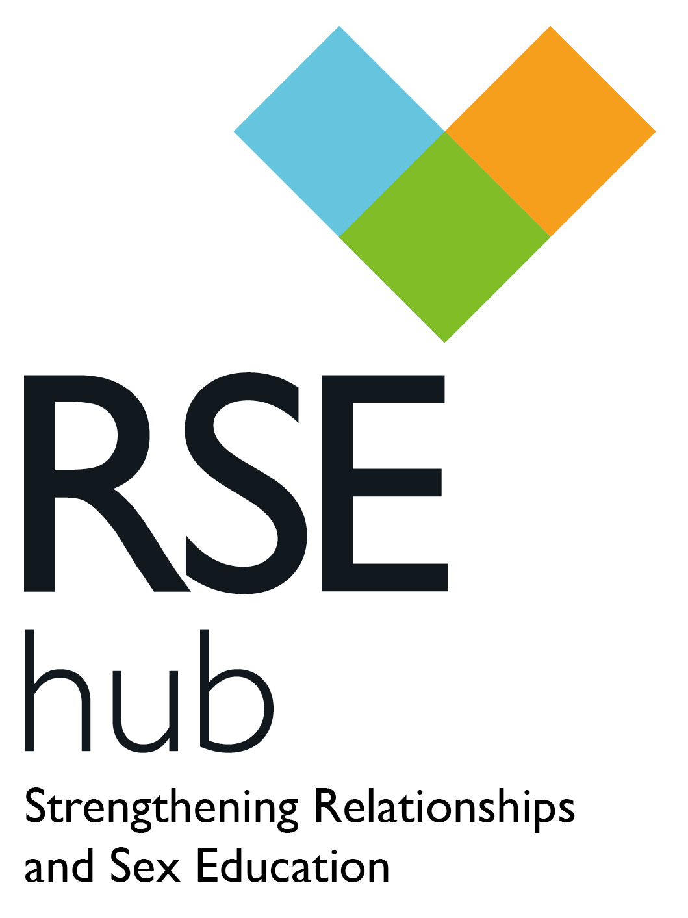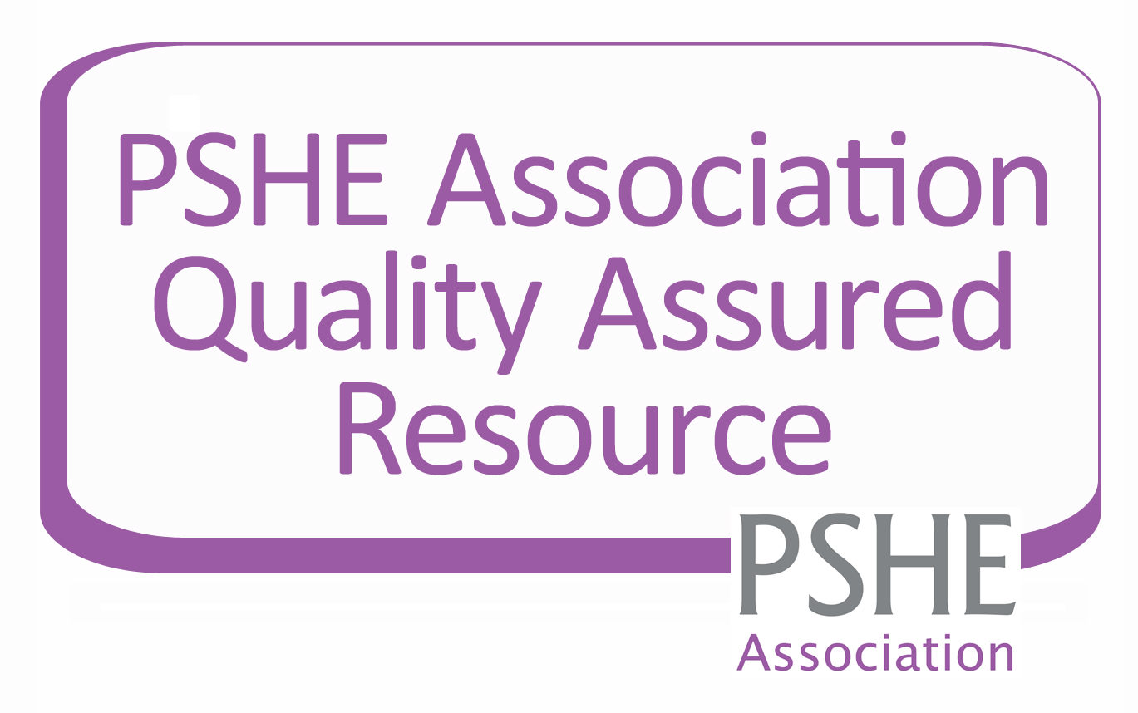

A Quality Review Framework for Relationships

and Sex Education in primary settings

Primary Review Framework for RSE

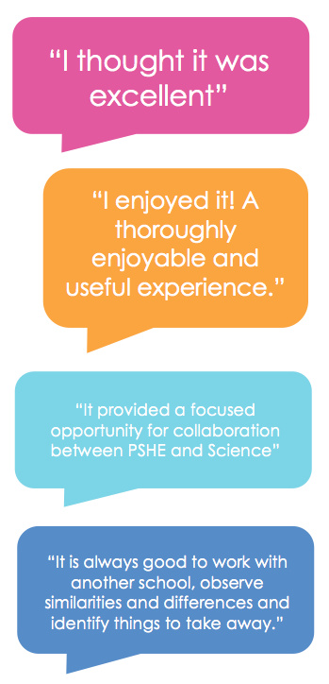

“It is always good to work with another school, observe similarities and differences and identify things to take away.”

The RSE Hub is delivered in partnership with the social enterprise The Exchange Foundation and continues to be guided by an advisory group of statutory, non-statutory and independent specialists. The RSE Hub aims to provide relevant credible and useful support for all aspects of Relationships and Sex Education.

This resource aims to help schools quality assure their RSE provision and create a development for sustained improvement as a whole school approach. This resource was developed following the pilot and evaluation of the Secondary Review Framework. This was successfully piloted in schools in Wiltshire and Bath & North East Somerset, demonstrating that it provided an effective and comprehensive basis for schools to evaluate their own and each other’s RSE provision within a framework of mutual support.

Additional copies may be purchased from <http://www.rsehub.org.uk/>

For more information or support with the Quality Review Framework please contact info@rsehub.org.uk

Published by the RSE Hub

All rights reserved. The purchase of this document enables the staff within one school to use this document to quality assure their existing provision. Apart from reprographic reproduction of the tables for completion purposes this document may not be reproduced, altered, or transmitted in any form between schools without the written permission of the RSE Hub.

© The RSE Hub 2014

Quality Criteria

Building on the core, these are the aspects of a developed RSE programme that add worth and value to children’s and young people’s learning experience and ensure it is related directly to their personal needs.

Core Criteria

These are the fundamentals that underpin a primary RSE programme – if any of these are lacking then urgent remedial action is required.

**What is the Primary Review Framework for RSE?**

The Primary Review Framework for RSE provides a set of criteria, which enable primary schools to review and develop the quality of their Relationships and Sex Education (RSE) provision, to ensure that they are effectively meeting children’s and young people’s entitlement in this essential area of learning.

**Who is the Primary Review Framework useful for?**

* Educators of RSE for 5-11 year olds
* Leaders of RSE within primary school settings.
* Leaders of RSE that work with schools to improve RSE delivery

The RSE Hub has also produced a similar framework for reviewing provision in secondary schools.

The review criteria are presented in two categories: **Core Criteria** and **Quality Criteria**, as defined below. This categorisation enables schools to focus their attention where their need is greatest, with the Core Criteria providing a minimum standard that all schools should expect to meet.

**Why complete the Primary Review Framework?**

Young people consistently say the RSE they receive is not good enough (SEF, 2008) and Ofsted have repeatedly found RSE provision to be weak in many schools (Ofsted, 2002, 2010, 2013). The Primary Review Framework was developed in order that schools can review, develop and improve their RSE, to ensure that the RSE they provide meets national guidelines and is of the highest standard.

The Primary Review Framework aims to enable schools, individually or in partnership, to undertake a review process at a level which seems manageable and appropriate to them.

**This process can be carried out as either a self or a peer review in partnership with other primary schools.**

NOTES FOR GUIDANCE

NOTES FOR GUIDANCE



**Intended Outcomes**

**Self Review**

Through participation in the Review process, schools will:

* Review and assess their own RSE provision with reference to a framework of criteria that are firmly grounded in current guidance and legislation
* Apply the findings of the review to formulate a development plan to enhance the experience of RSE for their pupils and staff.

INTENDED OUTCOMES

**Intended Outcomes**

**Peer Review**

* Review and assess their own RSE provision with reference to a framework of criteria that are firmly grounded in current guidance and legislation
* Refine and authenticate their self-review through the evaluative judgements of colleagues from a partner school
* Widen their perspective on the planning and delivery of RSE by undertaking the same critical evaluation of provision in the partner school
* Benefit from a constructive and mutually supportive professional   
  dialogue with colleagues in a similar school setting
* Apply the findings of the review to formulate a development plan to enhance the experience of RSE for their pupils and staff.

For schools undertaking the peer review process, it is worth noting that the experience of the pilot schools was that they benefited greatly from the support of external consultants (whether Local Authority or independent) in planning and conducting the review. Whilst the framework is intended to support a genuine peer-to-peer review process, the logistics of bringing a pair of schools together, managing the completion and sharing of the self-review, and planning and carrying out the review visits can be enhanced by the involvement of external advisers or consultants. The RSE Hub can act as a broker to enable schools to access this kind of support at a level appropriate to their needs and resources.

PRIMARY REVIEW – SELF REVIEW

Review

The self review is completed by the RSE lead within the school by checking appropriate boxes and noting appropriate evidence. The school should aim to achieve all core criteria as a minimum.

Deliver

The development plan is implemented for the rest of the academic year. At the end of the year the self review is revisited to gauge progress and identify additional areas for improvement in the next phase of the RSE development cycle.

Develop

The findings may be shared and agreed with the teaching and leadership team and

wider colleagues, and a development plan is

drawn up.

PRIMARY REVIEW – PEER REVIEW

Share

The self review (plus relevant documentary evidence) is shared with the peer review team.

Note on confidentiality

The peer review process is intended to be supportive and constructive. A key principle to be observed is that the review findings, as presented verbally and in writing by the review team, become the property of the school under review. The review team will maintain confidentiality with regard to their findings and feedback. The school itself will have discretion regarding whether and when to share the outcomes, which they may of course wish to do in order to access support from the local authority or any other source to support them with the implementation of their development plan.

Develop

Formulate development plan from the review findings. This can be reviewed with the

peer review team if necessary

Deliver

The development plan is enacted for the rest of the academic year. At the end of the year the review is revisited to gauge progress and identify additional areas for improvement in the next phase of the RSE development cycle.

Feedback

Feedback of findings from the peer review team.

Peer Review Visit

The peer review team use the self review to prepare for the review visit by formulating questions to be tested through observation, interview and discussion.

The peer review visit could include: Lesson observations and meetings with key stakeholders

Review

The self review is completed by those responsible for delivery of RSE related topics across the curriculum. The school should aim to achieve all core criteria as a minimum.



**Completing the review document**

Work through the document completing the sections you are able to at this stage. You may choose initially to focus only on reviewing the core criteria, aiming to build up to the quality criteria at a later stage.

Share the working document with other stakeholders for them to also add their contributions. Make notes of where the supporting evidence is located and any action points you might want to think about. Remember to save the document as you proceed.

Once you are happy that the document is an accurate reflection of RSE provision in your school, use the findings to complete the development plan in Appendix 1.

**For further help and support with completing this document contact info@rsehub.org.uk**

NOTES FOR GUIDANCE

**Current status of RSE & Key publications**

The criteria used in the review framework are based on the most relevant aspects of current legislation and guidance. A list of key publications for reference is located at the end of this document, and individual criteria can be cross-referenced to these publications as appropriate. As well as authenticating the review criteria, the publications referenced offer valuable additional guidance and support for the planning and delivery of the RSE programme. Appendix 2 of these guidance notes summarises the current position of RSE in the curriculum and the expectations placed on schools for the subject.

|  |  |
| --- | --- |
| School name |  |
| Head Teacher |  |
| School type and age range |  |
| Number on roll |  |
| Any special features  Eg. High FSM, BME, SEN, etc |  |
| PSHE Subject Lead |  |
| Science Subject Lead |  |
| SMSC / SEN Lead (with PSHE/Wellbeing remit) |  |
| PSHE / SMSC Link Governor |  |

SCHOOL FACTFILE

|  |  |  |  |  |  |  |
| --- | --- | --- | --- | --- | --- | --- |
| Subject Areas RSE is taught  e.g. PSHE, Science, RE, assemblies |  | | | | | |
| PD and PSED / PSHE Education  Average hours per week for discrete, timetabled PSHE | EYFS |  | KS1 |  | KS2 |  |
| National PSHE CPD  Number of accredited staff |  | | | | | |
| Clarifications…  Please use this space to explain for the review team any local abbreviations or acronyms used in your self-review below |  | | | | | |

SCHOOL FACTFILE

|  |  |
| --- | --- |
| No | This criterion is not met at all. |
| Yes, to some extent | This criterion is partially met. Specify which aspects are met and which require improvement. |
| Yes, Secure | All aspects of these criteria are met. |

Rating Criteria

|  |  |
| --- | --- |
| No | This criterion is not met at all. |
| Yes, to some extent | This criterion is partially met. Specify which aspects are met and which require improvement. |
| Yes, Secure | All aspects of these criteria are met. |

Rating Criteria

FOCUS 1 – LEADERSHIP AND MANAGEMENT - CORE

FOCUS 1 – LEADERSHIP AND MANAGEMENT - CORE

|  |  |  |
| --- | --- | --- |
| **Core Criteria** | **Rating** | **Observations Actions required, scope for development** |
| * 1. An identified subject leader holds responsibility for RSE, with appropriate status, time and senior leadership support | No  Yes, to some extent  Yes, Secure |  |
| * 1. An RSE policy statement is in place which has been updated within the last 3 years and meets national expectations | No  Yes, to some extent  Yes, Secure |  |
| * 1. The entitlement of all learners is secured through planned provision for RSE across the whole age range | No  Yes, to some extent  Yes, Secure |  |
| * 1. RSE is taught according to clear schemes of work in PSHE and Science which ensure age-appropriate learning and progression | No  Yes, to some extent  Yes, Secure |  |

FOCUS 2 – THE TEACHING TEAM - CORE

|  |  |  |
| --- | --- | --- |
| **Core Criteria** | **Rating** | **Observations Actions required, scope for development** |
| 2.1 Teachers of RSE are willing and committed to the teaching of this subject, and are supported as they gain and consolidate experience | No  Yes, to some extent  Yes, Secure |  |
| 2.2 Teachers of RSE have the necessary confidence, subject knowledge and classroom skills to deal with subject matter that can be sensitive and personal | No  Yes, to some extent  Yes, Secure |  |
| 2.3 Quality continuing professional development (CPD) is completed, every three years, by all staff who contribute to children’s learning in RSE including teachers and teaching assistants | No  Yes, to some extent  Yes, Secure |  |
| 2.4 Colleagues from external agencies, such as school nurses, contribute in a planned, integrated and quality-assured way to the RSE programme | No  Yes, to some extent  Yes, Secure |  |

FOCUS 2 – THE TEACHING TEAM - CORE

FOCUS 2 – THE TEACHING TEAM - CORE

FOCUS 3 – LEARNING AND TEACHING - CORE

FOCUS 3 – LEARNING AND TEACHING - CORE

|  |  |  |
| --- | --- | --- |
| **Core Criteria** | **Rating** | **Observations Actions required, scope for development** |
| 3.1 Consistent care is taken to create a safe and positive learning environment for RSE by agreeing ground rules with the children, and by clarifying that teachers have a safeguarding responsibility to all pupils | No  Yes, to some extent  Yes, Secure |  |
| 3.2 RSE lessons are taught with varied, active and experiential approaches, and include scope for pupils safely to ask questions and to learn by enquiry | No  Yes, to some extent  Yes, Secure |  |
| 3.3 Teachers employ varied and appropriate groupings for RSE lessons, including single sex groups where relevant | No  Yes, to some extent  Yes, Secure |  |
| 3.4 RSE teaching is supported by a range of good quality resources that are appropriate with regard to the pupils’ age, maturity and background, and reflect diversity | No  Yes, to some extent  Yes, Secure |  |
| 3.5 Learning in RSE is underpinned by a structured and consistent approach to assessing and recording pupils’ progress, including meaningful reporting to parents | No  Yes, to some extent  Yes, Secure |  |

|  |  |  |
| --- | --- | --- |
| **Core Criteria** | **Rating** | **Observations Actions required, scope for development** |
| 4.1 Consistent strategies are used to give pupils a voice and genuine influence in the planning, evaluation and development of RSE provision | No  Yes, to some extent  Yes, Secure |  |
| 4.2 RSE is seen as a partnership between school and home and there are effective measures to inform parents/carers, involve them in dialogue and consultation, and support them in discussing these issues with their children at home | No  Yes, to some extent  Yes, Secure |  |
| 4.3 All staff are clear about safeguarding/child protection procedures and what to do in the event of a disclosure or behaviour that warrants concern | No  Yes, to some extent  Yes, Secure |  |
| 4.4 Appropriate links are firmly established with local health, social and family support services, which are able to provide additional support to vulnerable children as required | No  Yes, to some extent  Yes, Secure |  |

FOCUS 4 – THE LEARNING COMMUNITY - CORE

FOCUS 4 – THE LEARNING COMMUNITY - CORE

FOCUS 5 – PROGRAMME CONTENT - CORE

FOCUS 5 – PROGRAMME CONTENT - CORE

|  |  |  |
| --- | --- | --- |
| **Core Criteria** | **Rating** | **Observations Actions required, scope for development** |
| **5.1 The RSE programme helps pupils to know and understand:** | | |
| 5.1.1 That there are male and female animals, which have offspring that grow into adults, as humans do | No  Yes, to some extent  Yes, Secure |  |
| 5.1.2 The names for the main parts of the body, including external genitals by Y4 and internal sexual/ reproductive anatomy by Y5. | No  Yes, to some extent  Yes, Secure |  |
| 5.1.3 How boys’ and girls’ bodies change as they approach and move through puberty and what they can do to manage these changes | No  Yes, to some extent  Yes, Secure |  |
| 5.1.4 The importance of and how to maintain personal hygiene | No  Yes, to some extent  Yes, Secure |  |

FOCUS 5 – PROGRAMME CONTENT - CORE

FOCUS 5 – PROGRAMME CONTENT - CORE

|  |  |  |
| --- | --- | --- |
| **5.1 The RSE programme helps pupils to know and understand:** | | |
| 5.1.5 That there are different types of families and that family and friends should care for each other | No  Yes, to some extent  Yes, Secure |  |
| 5.1.6 The process of growing from young to old and how people’s needs change | No  Yes, to some extent  Yes, Secure |  |
| 5.1.7 That there are different types of relationships, including those between friends and families, marriage and civil partnership | No  Yes, to some extent  Yes, Secure |  |
| 5.1.8 The physical facts of human reproduction, including conception and pregnancy | No  Yes, to some extent  Yes, Secure |  |
| 5.1.9 That sexual intercourse is part of an adult sexual relationship and is one way a couple can choose to start a family | No  Yes, to some extent  Yes, Secure |  |

FOCUS 5 – PROGRAMME CONTENT - CORE

FOCUS 5 – PROGRAMME CONTENT - CORE

|  |  |  |
| --- | --- | --- |
| **Core Criteria** | **Rating** | **Observations Actions required, scope for development** |
| **5.2 The RSE programme helps pupils to be able to:** | | |
| 5.2.1 Identify and respect the differences and similarities between people and to recognise stereotypes relating to, for instance, gender, sexual orientation, ethnicity, family unit and background | No  Yes, to some extent  Yes, Secure |  |
| 5.2.2 Identify their special people (family, friends, carers), what makes them special and how they should care for each other | No  Yes, to some extent  Yes, Secure |  |
| 5.2.3 Recognise what constitutes a positive, healthy relationship and to develop skills in forming and maintaining such a relationship | No  Yes, to some extent  Yes, Secure |  |
| 5.2.4 Recognise when and how to ask for help and use basic techniques for resisting unwanted pressure to do something which they believe to be wrong | No  Yes, to some extent  Yes, Secure |  |

|  |  |  |
| --- | --- | --- |
| **5.2 The RSE programme helps pupils to be able to:** | | |
| 5.2.5 Judge what kind of physical contact is acceptable or unacceptable and know how to respond, including who to tell and how to tell them | No  Yes, to some extent  Yes, Secure |  |
| 5.2.6 Distinguish the parts of our bodies that are considered public from those that are private, and the implications for what we display, touch or talk about | No  Yes, to some extent  Yes, Secure |  |
| 5.2.7 Develop skills so that they may be able to use social media, mobile and internet technology safely and appropriately | No  Yes, to some extent  Yes, Secure |  |

FOCUS 5 – PROGRAMME CONTENT - CORE

FOCUS 5 – PROGRAMME CONTENT - CORE

|  |  |  |
| --- | --- | --- |
| **Core Criteria** | **Rating** | **Observations Actions required, scope for development** |
| **5.3 The RSE programme helps pupils to think about:** | | |
| 5.3.1 Growing and changing and new opportunities and responsibilities that increasing independence may bring | No  Yes, to some extent  Yes, Secure |  |
| 5.3.2 How young people’s emotions change during puberty and how they might deal with these feelings in a positive way | No  Yes, to some extent  Yes, Secure |  |
| 5.3.3 How pressure to behave in an unacceptable, unhealthy or risky way can come from a variety of sources, including people they know | No  Yes, to some extent  Yes, Secure |  |
| 5.3.4 Appropriate strategies for keeping physically and emotionally safe in their relationships with others, including online relationships | No  Yes, to some extent  Yes, Secure |  |
| 5.3.5 How images in the media do not always reflect reality and can affect how people feel about themselves | No  Yes, to some extent  Yes, Secure |  |

FOCUS 5 – PROGRAMME CONTENT - CORE

FOCUS 5 – PROGRAMME CONTENT - CORE

FOCUS 1 – LEADERSHIP AND MANAGEMENT - QUALITY

FOCUS 1 – LEADERSHIP AND MANAGEMENT - QUALITY

FOCUS 5 – PROGRAMME CONTENT - CORE

FOCUS 5 – PROGRAMME CONTENT - CORE

FOCUS 5 – PROGRAMME CONTENT - CORE

FOCUS 5 – PROGRAMME CONTENT - CORE

|  |  |  |
| --- | --- | --- |
| **Quality Criteria** | **Rating** | **Observations Actions required, scope for development** |
| * 1. The RSE policy reflects a process of consultation within the school community | No  Yes, to some extent  Yes, Secure |  |
| * 1. Planning and delivery of the RSE curriculum is based on effective working relationships between the PSHE and Science Leads and class teachers | No  Yes, to some extent  Yes, Secure |  |
| * 1. The PSHE Lead has access to regular CPD opportunities in order to be able to support the teaching team to deliver RSE to a consistently high standard and to keep the curriculum up-to-date | No  Yes, to some extent  Yes, Secure |  |
| * 1. Provision for RSE is embedded in mainstream school planning, for instance through the School Development Plan, the school’s Equality Duty Objectives and in the agenda of the Governing Body | No  Yes, to some extent  Yes, Secure |  |

FOCUS 2 – THE TEACHING TEAM - QUALITY

FOCUS 2 – THE TEACHING TEAM - QUALITY

|  |  |  |
| --- | --- | --- |
| **Quality Criteria** | **Rating** | **Observations Actions required, scope for development** |
| 2.5 All class teachers have the knowledge and confidence to plan and deliver quality RSE to their pupils, and effectively engage their TAs in supporting the learning process | No  Yes, to some extent  Yes, Secure |  |
| 2.6 Good internal and home/school communications ensure teachers are aware of personal issues that may affect the issues addressed in lessons or pupils’ responses to them. Appropriate referral pathways for pupils are established if necessary. | No  Yes, to some extent  Yes, Secure |  |
| 2.7 All teaching staff have the confidence, knowledge and skills to deal with sensitive matters concerning puberty, relationships and inappropriate physical contact | No  Yes, to some extent  Yes, Secure |  |
| 2.8 The teaching of RSE is effectively monitored and supported, and all members of the team share in evaluation and development of the programme | No  Yes, to some extent  Yes, Secure |  |

FOCUS 3 – LEARNING AND TEACHING - QUALITY

FOCUS 3 – LEARNING AND TEACHING - QUALITY

|  |  |  |
| --- | --- | --- |
| **Quality Criteria** | **Rating** | **Observations Actions required, scope for development** |
| 3.6 RSE lessons support pupils in developing their own moral values, within a framework of understanding of family and cultural values | No  Yes, to some extent  Yes, Secure |  |
| 3.7 RSE lessons give pupils the confidence to explore sensitive issues and to understand the range of views people may hold about them | No  Yes, to some extent  Yes, Secure |  |
| 3.8 Strategies are in place to ensure the learning programme is responsive to the real needs of pupils, including the monitoring of local health data and of issues raised by the school nurse | No  Yes, to some extent  Yes, Secure |  |
| 3.9 Strategies are in place to identify and provide for specific individual needs in learning and personal development | No  Yes, to some extent  Yes, Secure |  |

FOCUS 4 – THE LEARNING COMMUNITY - QUALITY

FOCUS 4 – THE LEARNING COMMUNITY - QUALITY

|  |  |  |
| --- | --- | --- |
| **Quality Criteria** | **Rating** | **Observations Actions required, scope for development** |
| 4.5 A working partnership is established with neighbouring schools and a local secondary school, which serves to promote cross-phase continuity and progression in children’s experience of RSE during transition | No  Yes, to some extent  Yes, Secure |  |
| 4.6 In the school prospectus and public documents (newsletters, website, etc), vision statements reflect and support the school’s approach to RSE, and keynotes from the RSE policy are made available, including approach, content and parent/carer right to withdraw | No  Yes, to some extent  Yes, Secure |  |
| 4.7 The school’s processes for PR and communication with local media promote positive messages about RSE and wider PSHE provision and help to avoid or correct misperceptions | No  Yes, to some extent  Yes, Secure |  |

|  |  |  |
| --- | --- | --- |
| **Quality Criteria** | **Rating** | **Observations Actions required, scope for development** |
| **5.4 The RSE programme helps pupils to know and understand:** | | |
| 5.4.1 The link between positive self-esteem and being able to develop healthy friendships and relationships | No  Yes, to some extent  Yes, Secure |  |
| 5.4.2 The responsibilities of stable and committed adult relationships, including marriage and civil partnerships | No  Yes, to some extent  Yes, Secure |  |
| 5.4.3 The ways in which the media, and perceived norms and expectations in the peer group, can influence behaviour | No  Yes, to some extent  Yes, Secure |  |
| 5.4.4 How to identity and access trusted sources of help, support and information (including online) independently whilst keeping themselves safe | No  Yes, to some extent  Yes, Secure |  |

FOCUS 5 – PROGRAMME CONTENT - QUALITY

FOCUS 5 – PROGRAMME CONTENT - QUALITY

|  |  |  |
| --- | --- | --- |
| **Quality Criteria** | **Rating** | **Observations Actions required, scope for development** |
| **5.5 The RSE programme helps pupils to be able to:** | | |
| 5.5.1 Recognise and respect other people’s points of view, and express and justify their own | No  Yes, to some extent  Yes, Secure |  |
| 5.5.2 Develop confidence and assertiveness to resist peer pressure and negotiate within relationships | No  Yes, to some extent  Yes, Secure |  |
| 5.5.3 Challenge assumptions and stereotypes, especially those relating to the nine protected characteristics within the Equality Act (2010), about individuals, relationships and families | No  Yes, to some extent  Yes, Secure |  |
| 5.5.4 Recognise the stages of emotion related to loss and change, and how to seek help to manage these feelings positively | No  Yes, to some extent  Yes, Secure |  |

FOCUS 5 – PROGRAMME CONTENT - QUALITY

FOCUS 5 – PROGRAMME CONTENT - QUALITY

FOCUS 5 – PROGRAMME CONTENT - QUALITY

FOCUS 5 – PROGRAMME CONTENT - QUALITY

FOCUS 5 – PROGRAMME CONTENT - QUALITY

FOCUS 5 – PROGRAMME CONTENT - QUALITY

|  |  |  |
| --- | --- | --- |
| **Quality Criteria** | **Rating** | **Observations Actions required, scope for development** |
| **5.6 The RSE programme helps pupils to think about:** | | |
| 5.6.1 How the emotional changes that occur during puberty might affect their behaviour towards friends, families and carers and how they might deal with these feelings in a positive way | No  Yes, to some extent  Yes, Secure |  |
| 5.6.2 The responsibility for each other’s wellbeing – physical and emotional – that is implicit in friendships and relationships | No  Yes, to some extent  Yes, Secure |  |
| 5.6.3 The commitment being made by two adults who decide to start a family together | No  Yes, to some extent  Yes, Secure |  |
| 5.6.4 The qualities and values that make family life successful | No  Yes, to some extent  Yes, Secure |  |
| 5.6.5 The concept of keeping “something confidential or secret”, when we should or should not agree to this and when it is right to “break a confidence” or share a “secret” | No  Yes, to some extent  Yes, Secure |  |

APPENDIX 1 – DEVELOPMENT PLAN

APPENDIX 1 – DEVELOPMENT PLAN

FOCUS 5 – PROGRAMME CONTENT - QUALITY

FOCUS 5 – PROGRAMME CONTENT - QUALITY

|  |  |  |  |  |  |
| --- | --- | --- | --- | --- | --- |
| Focus | Review Summary | Actions | Who | Timescale | Evidence of success |
| Leadership and management |  |  |  |  |  |
|  |  |  |  |
|  |  |  |  |
|  |  |  |  |
|  |  |  |  |
| The teaching team |  |  |  |  |  |
|  |  |  |  |
|  |  |  |  |
|  |  |  |  |
|  |  |  |  |

School………………………………………………………………………………………………………………………………………………………………..

School………………………………………………………………………………………………………………………………………………………………..

|  |  |  |  |  |  |
| --- | --- | --- | --- | --- | --- |
| Learning and Teaching |  |  |  |  |  |
|  |  |  |  |
|  |  |  |  |
|  |  |  |  |
|  |  |  |  |
| Learning  Community |  |  |  |  |  |
|  |  |  |  |
|  |  |  |  |
|  |  |  |  |
|  |  |  |  |
| Programme  Content |  |  |  |  |  |
|  |  |  |  |
|  |  |  |  |
|  |  |  |  |
|  |  |  |  |

APPENDIX 1: DEVELOPMENT PLAN

APPENDIX 1: DEVELOPMENT PLAN

APPENDIX 2: RSE IN THE CURRICULUM

APPENDIX 2: RSE IN THE CURRICULUM

The current status of Relationships and Sex Education in the curriculum

The key documents relating to national guidance and legislation are referenced on page 31. This is current as of April 2014. If there are any further changes to the national guidance or legislation these will be updated via the RSE Hub website (<http://www.rsehub.org.uk/about-rse/statutory-requirements/>) and email list.

The key requirements included in the national guidance and legislation are as follows:

* All maintained schools are required to have an up to date Relationships and Sex Education (RSE) policy that describes the content and organisation of RSE where it is taught outside the Science curriculum (Learning and Skills Act, 2000).

The current status of Relationships and Sex Education in the curriculum

The key documents relating to national guidance and legislation are referenced on page 31. This is current as of April 2014. If there are any further changes to the national guidance or legislation these will be updated via the RSE Hub website (<http://www.rsehub.org.uk/about-rse/statutory-requirements/>) and email list.

The key requirements included in the national guidance and legislation are as follows:

* All maintained schools are required to have an up to date Relationships and Sex Education (RSE) policy that describes the content and organisation of RSE where it is taught outside the Science curriculum (Learning and Skills Act, 2000).
* Ofsted will evaluate how schools help to ensure a healthy lifestyle for their children (Ofsted, 2013, Subsidiary Guidance Para 64). Further details about Ofsted requirements are provided in Appendix 4.
* The Department for Health Framework for Sexual Health in England (2013) stated an ambition to build knowledge and resilience among young people by:
  + All children and young people receive good-quality sex and relationship education at home, at school and in the community.
  + All children and young people know how to ask for help, and are able to access confidential advice and support about wellbeing, relationships and sexual health.
  + All children and young people understand consent, sexual consent and issues around abusive relationships.
  + Young people have the confidence and emotional resilience to understand the benefits of loving, healthy relationships and delaying sex. (DH, 2013, Page 13)
* Ofsted will evaluate how schools help to ensure a healthy lifestyle for their children (Ofsted, 2013, Subsidiary Guidance Para 64). Further details about Ofsted requirements are provided in Appendix 4.
* The Department for Health Framework for Sexual Health in England (2013) stated an ambition to build knowledge and resilience among young people by:
  + All children and young people receive good-quality sex and relationship education at home, at school and in the community.
  + All children and young people know how to ask for help, and are able to access confidential advice and support about wellbeing, relationships and sexual health.
  + All children and young people understand consent, sexual consent and issues around abusive relationships.
  + Young people have the confidence and emotional resilience to understand the benefits of loving, healthy relationships and delaying sex. (DH, 2013, Page 13)
* It is compulsory for all maintained schools to teach the parts of sex education that fall under National Curriculum Science which must be taught to all pupils of primary and secondary age e.g. the biological aspects of puberty and reproduction (Education Act 1996, National Curriculum 2014)
* Academies are not obliged to have an SRE policy, nor are they bound by curriculum requirements. However they are required to have regard to the SRE Guidance 2000, and they are legally bound to provide a broad and balanced curriculum. (DfE, 2013)
* Sex and Relationships Education (SRE) is an important part of PSHE education. All schools must publish their PSHE curriculum including content of the RSE curriculum online. (DfE,2014)
* A curriculum summary by key stage, produced by the RSE Hub, is provided in Appendix 3.
* Governors of all schools must have ‘due regard’ to the Sex and Relationship Education Guidance published in 2000 by the DfE (Learning and Skills Act, 2000).
* Schools have a legal duty to promote the well-being of their pupils (Education and Inspections Act 2006 Section 38)
* It is compulsory for all maintained schools to teach the parts of sex education that fall under National Curriculum Science which must be taught to all pupils of primary and secondary age e.g. the biological aspects of puberty and reproduction (Education Act 1996, National Curriculum 2014)
* Academies are not obliged to have an SRE policy, nor are they bound by curriculum requirements. However they are required to have regard to the SRE Guidance 2000, and they are legally bound to provide a broad and balanced curriculum. (DfE, 2013)
* Sex and Relationships Education (SRE) is an important part of PSHE education. All schools must publish their PSHE curriculum including content of the RSE curriculum online. (DfE,2014)
* A curriculum summary by key stage, produced by the RSE Hub, is provided in Appendix 3.
* Governors of all schools must have ‘due regard’ to the Sex and Relationship Education Guidance published in 2000 by the DfE (Learning and Skills Act, 2000).
* Schools have a legal duty to promote the well-being of their pupils (Education and Inspections Act 2006 Section 38)

The table below sets out one way in which the core learning criteria could be allocated within each key stage in order to develop an age-appropriate spiral curriculum. It is informed by the learning aims of the EYFS framework, the National Science Curriculum and the PSHE Association’s Programme of Study for PSHE.

APPENDIX 3: GUIDE TO CORE LEARNING BY KEY STAGE

APPENDIX 3: GUIDE TO CORE LEARNING BY KEY STAGE

|  |  |
| --- | --- |
| EYFS &  KEY STAGE ONE  YEARS R, 1 AND 2 | * That there are male and female animals, which have offspring that grow into adults, as humans do * The names for the main parts of the body, including the male and female private parts * The importance of and how to maintain personal hygiene * That there are different types of families and that family and friends should care for each other * Identify and respect the differences and similarities between people and to recognize and challenge stereotypes * Identify their special people (family, friends, carers), what makes them special and how they should care for each other * Growing and changing and new opportunities and responsibilities that increasing independence may bring |
| LOWER  KEY STAGE TWO  YEARS 3 AND 4 | * How boys’ and girls’ bodies change as they approach and move through puberty * The process of growing from young to old and how people’s needs change * That there are different types of relationships, including those between friends and families * Recognise when and how to ask for help and use basic techniques for resisting unwanted pressure to do something which they believe to be wrong * Judge what kind of physical contact is acceptable or unacceptable and know how to respond, including who to tell and how to tell them * Appropriate strategies for keeping physically and emotionally safe in their relationships with others |
| UPPER  KEY STAGE TWO  YEARS 5 AND 6 | * How boys’ and girls’ bodies change as they approach and move through puberty and what they can do to manage these changes * The importance of and how to maintain personal hygiene * That there are different types of relationships, including those between friends and families, marriage and civil partnership * The physical facts of human reproduction, including conception and pregnancy * That sexual intercourse is part of an adult sexual relationship and is one way a couple can choose to start a family * Recognise what constitutes a positive, healthy relationship and to develop skills in forming and maintaining such a relationship * How pressure to behave in an unacceptable, unhealthy or risky way can come from a variety of sources, including people they know * Appropriate strategies for keeping physically and emotionally safe in their relationships with others, including online relationships * How images in the media do not always reflect reality and can affect how people feel about themselves |

Ofsted

In 2013 Ofsted reported that PSHE including RSE was still not good enough. Relationships and Sex Education required improvement in over a third of schools. It found that in primary schools this was because too much emphasis was placed on maintaining friendships and this left pupils ill-prepared for puberty, which many begin to experience before they reach secondary school, and lacking in knowledge about reproduction and how babies are born.

Ofsted note that lack of age-appropriate RSE may leave young people vulnerable to inappropriate sexual behaviours and sexual exploitation, particularly if they are not taught the appropriate language, or have not developed the confidence to describe unwanted behaviours, or do not know who to go to for help.

The Ofsted inspection framework requires that PSHE/RSE lessons are subject to the same expectations as other subjects in relation to the achievement of pupils and the quality of teaching.

RSE within the PSHE programme will make a significant contribution to Ofsted judgements of the school’s provision under ‘Behaviour and Safety of Pupils’ (particularly with regard to issues around prejudice-based bullying) and under ‘Leadership and management’.

Personal development is also reported on within the wider category of ‘Spiritual, Moral, Social and Cultural Development’. The guidance for inspectors carrying out subject-specific survey visits for PSHE education is instructive as to the features that are seen to characterise high quality provision for PSHE.

The extracts presented in the table on the next page are taken from the subject-specific grade descriptors for a school to be rated as ‘Outstanding’, picking out only those points that have particular relevance to RSE provision:

APPENDIX 4: OFSTED

APPENDIX 4: OFSTED

APPENDIX 4: OFSTED

APPENDIX 4: OFSTED

|  |  |
| --- | --- |
| **Area for inspection** | **‘Outstanding’ grade descriptors for PSHE education**  **(Selected points correlating closely to criteria in the RSE quality review framework)** |
| Achievement of students in PSHE education | Pupils show outstanding understanding of, and commitment to, their own and others’ health and wellbeing. Pupils, appropriate to their age and capability, have an excellent understanding of relationships, sexual development, sexual consent and respect. They understand extremely well how to keep themselves and others healthy and safe.  Pupils know how to resist peer pressure effectively and know very well where to go to seek further help and advice if they need it.  All pupils understand very well the impact of bullying on others and actively challenge all forms of bullying. |
| Quality of teaching in PSHE education | Teachers demonstrate very high levels of confidence and expertise in their specialist knowledge and in their understanding of effective learning in PSHE.  Teachers use a very wide range of imaginative resources and strategies to stimulate students’ interest and active participation.  Teachers are confident and skilled in discussing sensitive and/or controversial issues. Effective discussion is a very strong feature; pupils are encouraged to investigate, express opinions and listen  to others. |
| |  |  | | --- | --- | | The curriculum in PSHE education | The imaginative and stimulating PSHE curriculum is skilfully designed to match the full range of pupils’ needs, interests and aspirations and to ensure highly effective continuity and progression in their learning across all key stages. The programme is explicit, comprehensive and coherent. The statutory elements of sex and relationships education (SRE) are fully met.  Local data is fully taken into account when planning.  Pupils and teachers are fully engaged in influencing the content and evaluating the quality of the curriculum. | | Leadership and management of PSHE education | Leadership is informed by a high level of PSHE expertise and vision.  The subject is very well resourced in terms of curriculum time, staff training, management time and the use of external services and materials.  Statutory requirements in SRE are fully met. The monitoring of teaching and learning in PSHE is rigorous; subject reviews, self-evaluation and improvement planning are well informed by current best practice.  There are highly effective strategies to share good practice and secure high quality professional development.  Very strong links exist with partner schools, parents, carers and external agencies to reinforce the very high standard of PSHE education. | | |

APPENDIX 4: OFSTED

APPENDIX 4: OFSTED

The criteria in the Quality Review framework are all grounded in national legislation   
and guidance as referenced in the documents listed below:

The criteria in the Quality Review framework are all grounded in national legislation   
and guidance as referenced in the documents listed below:

REFERENCES

REFERENCES

* Department for Education and Skills (DFES), (2007) ‘The Early Years Foundation Stage’, London DFES.
* Department for Health (2013) *A Framework for Sexual Health Improvement in England.* Crown Copyright.
* Education Act (1996), Section 407
* Education and Inspections Act 2006 Section 38
* Learning and Skills Act (2000) Section 148
* Ofsted (2013) Not Yet Good Enough, Personal, social, health and economic education in schools (Ofsted 130065)
* Ofsted (2010): Personal, Social, Health and Economic Education in schools   
  (Ofsted 090222)
* Ofsted (2002): Sex and Relationships Education (HMI 433)
* PSHE Association (2013) A New Programme of Study for PSHE Key Stages 1-4. Available from <http://www.pshe-association.org.uk/uploads/media/27/7783.pdf>
* National Children’s Bureau – Sex Education Forum:
  + 2013: Let’s Get It Right: A toolkit for involving primary school children in reviewing their sex and relationship education (for purchase)
  + 2011: Current Status of Sex and Relationships Education
  + 2010: Understanding Sex and Relationships Education
  + 2010: External Visitors and Sex and Relationships Education
  + 2005: Effective Learning Methods: approaches to teaching about sex and relationships within PSHE and Citizenship
  + 2003: Sex and Relationships Education: Support for School Governors
  + 2003: Talk to your children about sex and relationships: support for parents
* National Children’s Bureau – Sex Education Forum:
  + 2013: Let’s Get It Right: A toolkit for involving primary school children in reviewing their sex and relationship education (for purchase)
  + 2011: Current Status of Sex and Relationships Education
  + 2010: Understanding Sex and Relationships Education
  + 2010: External Visitors and Sex and Relationships Education
  + 2005: Effective Learning Methods: approaches to teaching about sex and relationships within PSHE and Citizenship
  + 2003: Sex and Relationships Education: Support for School Governors
  + 2003: Talk to your children about sex and relationships: support for parents
* Blake and Muttock (2004): Assessment, Evaluation and Sex and Relationships Education: a practical toolkit for education, health and community settings (for purchase)
* Brook, PSHE Association and Sex Education Forum (2014): Sex and Relationships Education for the 21st Century
* Department for Education and Employment (2000): Sex and Relationship Education Guidance (DfEE 0116/2000).
* Department for Education (2013) Guidance document for Personal Social & Health Education.
* Department for Education (2011): Healthy Schools Toolkit – Whole School Review Template
* Department for Education (2014) Mandatory Reporting Timeline for Schools: <http://www.education.gov.uk/schools/toolsandinitiatives/cuttingburdens/b00216133/need-to-know-schools/mandatory>
* Department for Education (2014) The National Curriculum in England Framework document
* Blake and Muttock (2004): Assessment, Evaluation and Sex and Relationships Education: a practical toolkit for education, health and community settings (for purchase)
* Brook, PSHE Association and Sex Education Forum (2014): Sex and Relationships Education for the 21st Century
* Department for Education and Employment (2000): Sex and Relationship Education Guidance (DfEE 0116/2000).
* Department for Education (2013) Guidance document for Personal Social & Health Education.
* Department for Education (2011): Healthy Schools Toolkit – Whole School Review Template
* Department for Education (2014) Mandatory Reporting Timeline for Schools: <http://www.education.gov.uk/schools/toolsandinitiatives/cuttingburdens/b00216133/need-to-know-schools/mandatory>
* Department for Education (2014) The National Curriculum in England Framework document

