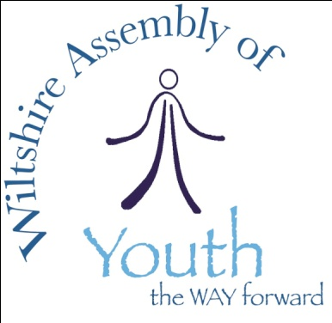
UK Youth Parliament

ELECTION 2019 Application Form

Candidate name:

Address:

Postcode:
Email:

Phone: Mobile:
Date of birth:
School/college:
I am standing for the seat in
☐ Wiltshire East ☐ Wiltshire North ☐ Wiltshire West
(refer to constituency area map)

☐ I understand that by standing as a candidate in these elections I must submit a video no longer than 60 seconds in length and that this video will be posted on YouTube/Wiltshire Council website until the end of the election period.

☐ I understand that if elected to the UK Youth Parliament I must also be a committed member of the Wiltshire Assembly of Youth, attend and lead meetings and related activities.
☐ I understand that as a member of UK Youth Parliament and Wiltshire Assembly of Youth my job is to represent the voices of children and young people from the constituency I am elected to.

By MONDAY 26 NOVEMBER 2018 you need to have

- Returned this Application and Parent/Carer Consent Form to voiceandinfluenceteam@wiltshire.gov.uk
- Uploaded your video manifesto to https://free.mailbigfile.com/ and sent to voiceandinfluenceteam@wiltshire.gov.uk

Your manifesto

A manifesto is a statement in which you have a chance to say what your aims and your key areas of interest are, including what you will be fighting for should you be elected.

Use this space to tell us briefly (no more than 250 words) what you stand for and why Wiltshire’s young people should vote for you. You can use this as a script for your video if you wish to.

My name is ….

I live in _____________________ and go to ______________________school

If I am elected to Youth Parliament I will be campaigning on 2 (or 3) important issues.
The first is ….

The second is …

I consider these to be important issues because …

If I am elected to Youth Parliament, I promise to …

Questions?
Contact Sarah on 07342 064355 or email sarah.banks@wiltshire.gov.uk
Wiltshire Council Youth Voice Meetings Activities
Consent Form

Participant details
Name
Address & postcode

Date of Birth
Home phone
Mobile phone
Email address

Parent/Guardian details
Name
Address
(if different from above)
Home &
mobile phone
Emergency contact details
Email address

Medical information
Participant’s GP name
GP practice address
GP practice phone number
Details of participant's food allergies or other special dietary needs

Details of participant's medical allergies, medical requirements or other special needs (Please provide full details of dosage and who is to administer any medication that may be required on the medical form attached)

Has your son/daughter/ward received a tetanus in the last five years? Yes No

Any other details of which we should be aware?

Does the young person suffer from any of the following?
Please give details of condition and medication/administration required.
Unable to perform moderate exercise

Any back arm or leg problems
History of recurrent back problems or surgery

Asthma

Any types of hernia

Acute fear of water

Vertigo or problems with balance

Impairment of sight, hearing or speech

Recurring dizziness

Recurring migraine headaches or taking medication to prevent them

Hay fever or allergies

Diabetes

Epilepsy, Seizures, Convulsions or taking medication to prevent them

High blood pressure

History of heart attacks/angina

Regularly take some form of medication

Any other condition which you feel may affect their participation in the course of these activities

Transport and travel
Your child/ward will at times be required to travel by public transport, prepaid taxis (where the drivers have all received Council approved DBS checks), or in a private car or Wiltshire Council MPV/Minibus with a member of Wiltshire Council staff. By signing this consent form, you are accepting this as part of the terms of their involvement for the activity listed above.

DECLARATION: PARENT/GUARDIAN (of participants under 18 years of age)
I can confirm that:

- I have read and fully understand the information relating to the proposed activity;
- I am satisfied that all reasonable care will be taken for the safety of those participating and that adequate staffing and safety measures have been arranged;
- I consider my son/daughter/ward to be medically fit to participate in the activities outlined and agree to inform you should this situation change between now and the activity date;
- I agree to my son/daughter/ward receiving medication and any emergency dental, medical or surgical treatment, including anaesthetic, as considered necessary by the medical authorities present;
- My son/daughter/ward is solely responsible for any expensive electrical items that they bring to this activity, and that I have advised them to keep any device switched of for the duration of the activity (or as instructed by group leader).

Name:

Signed: Date:

DECLARATION: PARTICPANT (all and any age)
I, as a participant in the stated activity, agree to abide by the rules and act upon the instructions of staff and to notify staff if I am unable to attend.

Name:

Signed: Date:

Email this completed form to voiceandinfluenceteam@wiltshire.gov.uk

