Email: [parenting@wiltshire.gov.uk](mailto:parenting@wiltshire.gov.uk)

Parental Relationship and Parenting Programmes

**Being a parent can be amazing, but we all need some help, advice, and practical tips at times. Parenting programmes can provide just that, whether its from our trained facilitators or other parents and carers. We offer courses that are suitable from pregnancy all the way up to age 18.**

**Parental Relationship Courses:**

**OnePlusOne**

**TRIPLE P FAMILY TRANSITIONS**

**WITHIN MY REACH**

**Parenting Courses:**

**PREGNANCY TO PARENTHOOD**

**BEING A PARENT**

**TIME OUT FOR PARENTS (children with additional needs)**

**TRIPLE P (positive parenting programme)**

**SWAPP (autism parenting programme)**

**STOP (pre-teen and teen parenting)**

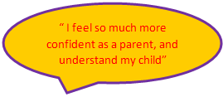

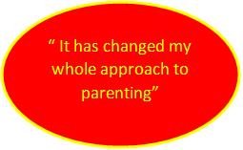

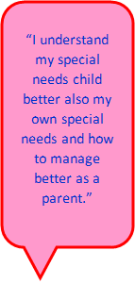



“I felt so lost and alone, but this course helped with more than just my parenting”



“I have skills to cope better.”

“How to communicate and have a calm conversation when times are stressful”