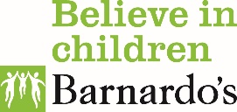 | 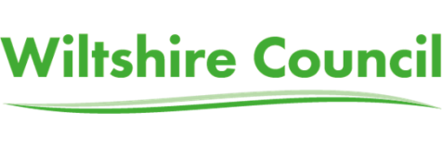

Wiltshire Early Mental Health and Counselling Support Service

Who are we?

Barnardo’s has been commissioned by Wiltshire Council to improve outcomes for children and young people with emotional wellbeing and/or emerging low level mental health needs.
The service provides a range of evidence based interventions, information, advice, support and positive activities

Who do we support?

Children and young people aged 5-18 who may be experiencing
- low mood
- panic, stress, worry and low level anxiety
- have problems sleeping
- have anger difficulties
- have low self-esteem
- relationship difficulties with family or friends
- relationship problems at school or in the community (including bullying),
- Feeling overwhelmed by pressure eg in relation to school work.

What do we offer?

Current changes to service offer due to Covid-19 in italics

On Your Mind website – www.onyourmind.org.uk

Information for young people and for parents / carers including links to resources and organisations that can support with emotional wellbeing.
A webchat facility and webinars for parents are currently being developed.

Decider skills groups – currently a one to one online offer
A programme based on cognitive-behavioural therapy to build skills and strategies for children and young people and their families. Groups will be delivered for primary aged and secondary aged children and young people to build resilience and wellbeing.

Positive activities – in development
Activities which will be co designed with young people and delivered in partnership with other Wiltshire services to promote the 5 steps to wellbeing.

Counselling / therapy – currently an online or phone offer only
- For children and young people aged 5-18 who are not currently accessing CAMHs or another similar wellbeing intervention.
- An average of 6 sessions
- Provided online, by phone or face to face.

We are working closely with other specialist providers in Wiltshire, including CAMHS services who will be working with young people with more complex needs eg psychosis, PTSD, bipolar, personality disorders, eating disorders, chronic anxiety or depression, enduring self-harm and OCD.

The service is underpinned by our commitment to being child-centred working in partnership with children and young people and adopting a systems approach that recognises that children and young people do not live in isolation from their families and communities.

To request support from the service please visit www.onyourmind.org.uk.

We are moving towards all requests coming to us via a Single Point of Access shared with CAMHS so children, young people and their parents / carers only have to tell their story once. Further information will be provided once the SPA is fully functional.

For more information please email the service at
Info.wiltsemh@barnardos.org.uk
Tel: 07849 306876

