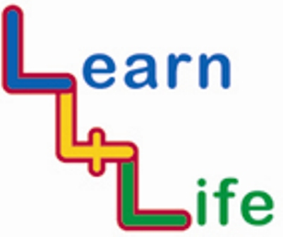

WHOLE SCHOOL HEALTH WEEK
KS2 Transition Package

KEY LEARNING OUTCOMES

- For children to feel comfortable going to Secondary school.
- For secondary school teachers to get to know the children prior to them coming to secondary school.

LAUNCH EVENT

Based at the primary school a team building day involving year six pupils, some year seven pupils, year seven tutors, year six teachers and head of year seven.
Activities could include drama activities, problem solving, orienteering, survival skills etc.
FAMILY LEARNING ACTIVITY

The Extended Services Co-ordinator could run workshops for parents to help them understand their role in transition.

CELEBRATION EVENT (FINALE)

Another team building day similar to the launch event with the same people taking part but at the Secondary School. This could be done as part of one of the Secondary School transition days.

Class-based activities that are linked to the PSHE themes that can be done in conjunction with Secondary schools.

HEALTHY EATING

The year six children could use the DT suite, Science department and/or teachers at the secondary school to carry out healthy eating projects for example tuck shops.

PHYSICAL ACTIVITY

Schools could organise intra sports events where year sixes and year sevens could play against or with each other.

ENTERPRISE/FAIR TRADE

The secondary school Business Studies students could plan, organise and run an enterprise activity with the year six children. This could also be with RE students or PSHEE or Citizenship students.

CYBER SAFETY

Secondary pupils run an assembly or workshops on internet safety, cyber bullying. Probably not suitable to include younger children as some of the content can be disturbing.

GLOBAL AWARENESS

Geography department, Languages department and RE department could work collaboratively on projects. Teachers could use their specialist skills to help with teaching at the Primary school.

GREEN ISSUES

Green flag projects, collaborative working involving eco squads, science, geography and DT departments. Community working groups e.g. Bloomers.

OUT AND ABOUT

Looking at the community that the schools are in. Transition days and residential courses.

ANTI BULLYING

Who to go to when things don’t go right. Year seven pupils present information on what the Secondary schools rules are. What happens when things go right/wrong?

Year sevens as buddies/contacts.

Link to launch event.
PASSPORT – ‘THIS IS ME’

The passport is similar to the one in the Kaleidoscope, year Nine, week 6, and Spring term. Also, links to Being me in year Seven.
It is intended to be a document that can be passed on to secondary school teachers/tutors to give them an insight into the children.

