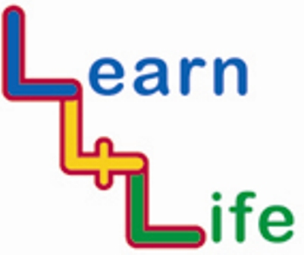
TEACHER ASSESSMENTS

UKS2 Year 6 / Year B |  | Remark on the “remarkable”
 |  | Very high achievers | Very low achievers
Autumn 1  Our Happy School | I know how to work well in a group
Autumn 1  Our Happy School | I can listen to and show respect for other people’s views when working in a group
Autumn 2  Out and About | I know how to protect myself on-line
Autumn 2  Out and About | I can use my skills for solving problems peacefully to help other people resolve conflict
Spring 1  Looking Forward | I can help organize an enterprise activity
Spring 1  Looking Forward | I know it is up to me to get things done by taking the first step
Spring 2  My Friends and Family | I know some of the feelings that people have when someone close dies or leaves
Spring 2  My Friends and Family | I can recognise and challenge stereotyping and discrimination
Summer 1  Healthy Bodies, Healthy Minds | I know why I should exercise
Summer 1  Healthy Bodies, Healthy Minds | I know what addiction means
Summer 1  Healthy Bodies, Healthy Minds | I understand that sometimes the feeling part of my brain takes over and I might make mistakes
Summer 2  Ready, Steady, Go | I know that sometimes there can be positive outcomes from changes that we didn’t welcome initially
Summer 2  Ready, Steady, Go | I can look for the positives in big changes I am facing

