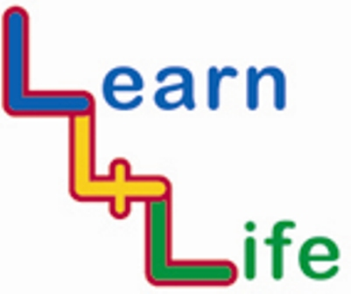
TEACHER ASSESSMENTS

LKS2 Year 4 / Year B |  | Remark on the “remarkable”
 |  | Very high achievers | Very low achievers
Autumn 1  Our Happy School | I know what it feels like to be unwelcome
Autumn 1  Our Happy School | I can work with others to achieve a shared goal
Autumn 2  Out and About | I know how to enjoy fireworks safely
Autumn 2  Out and About | I can use peaceful problem solving to sort out difficulties
Spring 1  Looking Forward | I know what can influence how people spend or save
Spring 1  Looking Forward | I know I am responsible for my own learning and behaviour
Spring 2  My Friends and Family | I know the names for male and female body parts
Spring 2  My Friends and Family | I can take responsibility for what I choose to do
Summer 1  Healthy Bodies, Healthy Minds | I know I am responsible for taking exercise to look after my body
Summer 1  Healthy Bodies, Healthy Minds | I know how to say no, if offered a cigarette
Summer 1  Healthy Bodies, Healthy Minds | I can stop and think before I act
Summer 2  Ready, Steady, Go | I know some ways of dealing with changes that make me feel uncomfortable
Summer 2  Ready, Steady, Go | I know some ways of dealing with the feelings that arise from changes

