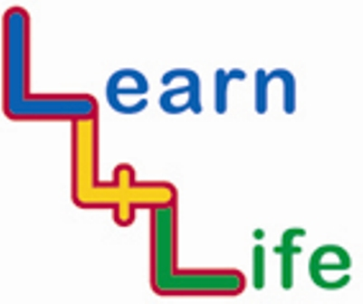
TEACHER ASSESSMENTS

LKS2 Year 3 / Year A |  | Remark on the “remarkable”
 |  | Very high achievers | Very low achievers
Autumn 1  Our Happy School | I know something about everyone in my class
Autumn 1  Our Happy School | I can work in a cooperative way with others
Autumn 2  Out and About | I know how to take turns when talking
Autumn 2  Out and About | I can spot dangers in the home including dangers online
Spring 1  Looking Forward | I know some enterprising ways I can support a charity
Spring 1  Looking Forward | I know how others can help me achieve my goals and how I can help others
Spring 2  My Friends and Family | I know that families can be different from one another
Spring 2  My Friends and Family | I can say no to peer pressure
Summer 1  Healthy Bodies, Healthy Minds | I know that eating too much salt, sugar and fat is bad for me
Summer 1  Healthy Bodies, Healthy Minds | I can recognise when I find something difficult and do something about it or cope with how that makes me feel
Summer 2  Ready, Steady, Go | I know some people who I can turn to for help at difficult times
Summer 2  Ready, Steady, Go | I know that everybody goes through many sorts of change all the time

