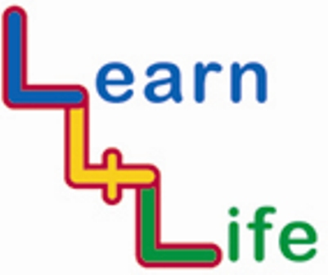
TEACHER ASSESSMENTS

KS1 Year 2 / Year B |  | Remark on the “remarkable”
 |  | Very high achievers | Very low achievers
Autumn 1  Our Happy School | I know how I can help make my classroom a safe and happy place
Autumn 1  Our Happy School | I can welcome someone into my class
Autumn 2  Out and About | I know about stranger danger including meeting strangers online
Autumn 2  Out and About | I can work well in a group
Spring 1  Looking Forward | I know that you can choose to spend or save money
Spring 1  Looking Forward | I can choose between my ideas and give reasons
Spring 2  My Friends and Family | I know the stages of a life cycle
Spring 2  My Friends and Family | I can identify some of the people who care for me
Summer 1  Healthy Bodies, Healthy Minds | I know why I should eat 5 portions of fruit and veg a day
Summer 1  Healthy Bodies, Healthy Minds | I know what makes me feel relaxed and what makes me feel stressed
Summer 2  Ready, Steady, Go | I know how to cope with changes that can be exciting or worrying
Summer 2  Ready, Steady, Go | I can plan to overcome obstacles that might get in the way

