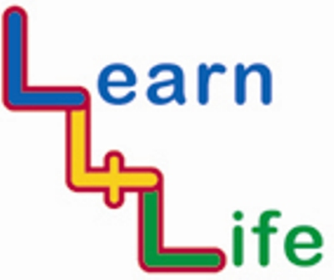
TEACHER ASSESSMENTS

KS1 Year 1 / Year A |  | Remark on the “remarkable”
 |  | Very high achievers | Very low achievers
Autumn 1  Our Happy School | I know why we have rules in school
Autumn 1  Our Happy School | I can tell you how I am the same and different from my friends
Autumn 2  Out and About | I know how to be careful when walking on the pavement
Autumn 2  Out and About | I can listen well to other people when they are talking
Spring 1  Looking Forward | I can tell you about the different types of work people do
Spring 1  Looking Forward | I can tell you some of my strengths as a learner
Spring 2  My Friends and Family | I know who my friends and families are
Spring 2  My Friends and Family | I can make people I care about happy
Summer 1  Healthy Bodies, Healthy Minds | I know that exercise keeps me fit and healthy
Summer 1  Healthy Bodies, Healthy Minds | I know not to touch medicines and that substances in the house can be dangerous
Summer 1  Healthy Bodies, Healthy Minds | I can tell you something that makes me feel proud
Summer 2  Ready, Steady, Go | I know my friends can help me and I can help them in times of change
Summer 2  Ready, Steady, Go | I know that some changes are natural and “happen by themselves”

