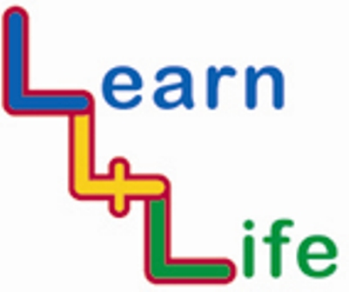
YR 6 PUPIL SELF ASSESSMENT

R = I am still finding this difficult  A = I am doing well with this  G= I feel confident and am ready for new challenges  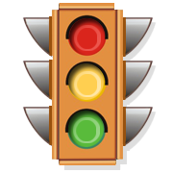 | Assessment statement  I have thought about.... | Teacher Comment
Autumn 1 | I have thought about what makes a group function well so that we can learn together
Autumn 2 | I have thought about strategies I can use to stay safe when faced with risky situations
Spring 1 | I have thought about how money affects the way I live
Spring 2 | I have thought about how the media can influence the way we think and feel about people and situations
Summer 1 | I have thought about what I can do when I feel pressured such as……
Summer 2 | I have thought about the positive aspects of moving on to secondary school.

