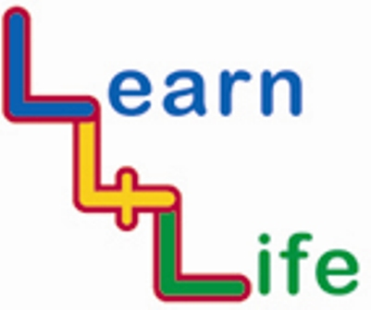
YR 5 PUPIL SELF ASSESSMENT

R = I am still finding this difficult  A = I am doing well with this  G= I feel confident and am ready for new challenges  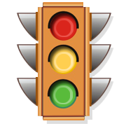 | Assessment statement  I have thought about.... | Teacher Comment
Autumn 1 | I have thought about the importance of rules and of keeping them
Autumn 2 | I have thought about how stereotyping can affect people in different ways
Spring 1 | I have thought about how to save up for an item I want and how I might need to restrict my other spending to do so.
Spring 2 | I have thought about how my body will change during puberty, how I may feel, and what to do about these feelings
Summer 1 | I have thought about how I can have a healthy mind and body by……….
Summer 2 | I have thought about how to deal with difficult feelings to do with loss

