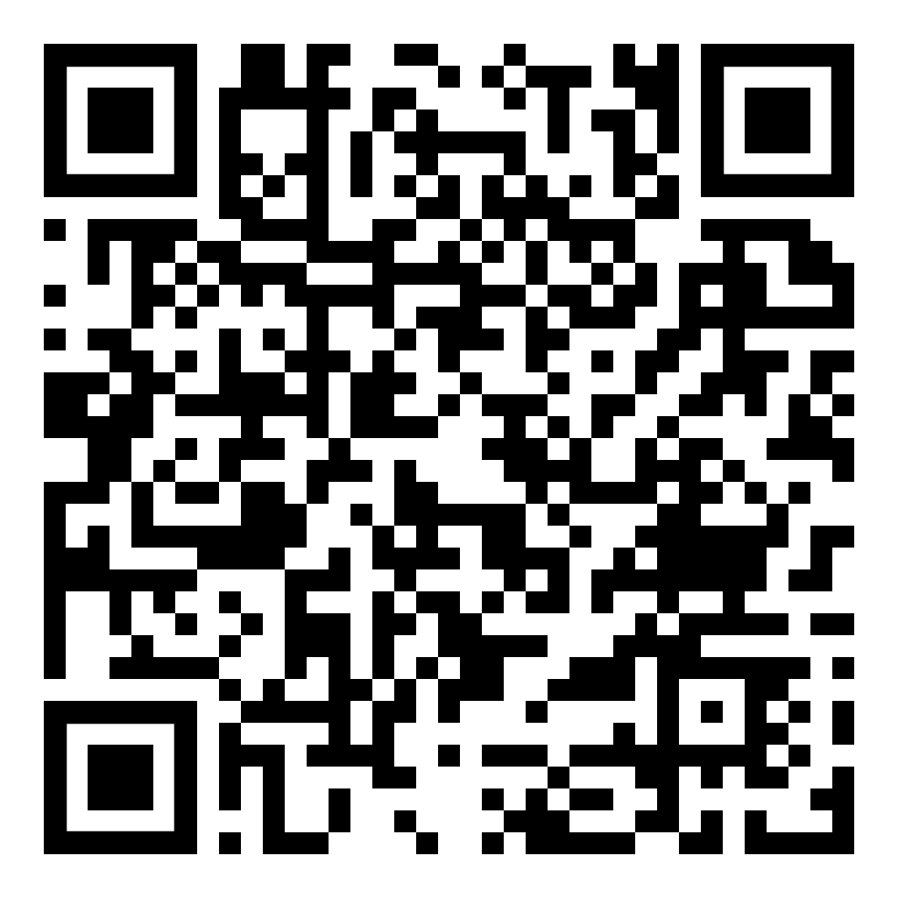
Under 18 free,
confidential support
to stop
vaping or smoking

Over 18 free,
confidential support
to stop
smoking

