The Wiltshire Police Youth and Early Intervention team works with schools, colleagues and partners to share messages and educate young people. The aim is to keep young people in our community safe.

Each school has an allocated Community Policing Team Police Community Support Officer (PCSO) as a point of contact. If you are not sure who this is, for confirmation please email YouthSwindon@wiltshire.pnn.police.uk if your school is based in Swindon or youth@wiltshire.pnn.police.uk for schools based across the rest of the county.

As there are new campaigns on safety and crime prevention happening, we would like to update you on how we can support your school.

Computer Misuse Act (1990) – Key Information for Schools, Trusted Adults and Young People

As Christmas is fast approaching, children and young people will soon be receiving their presents, which can include the latest gadgets that have access to the Internet.
Technology and computers are fantastic - they help us to learn, share, communicate and find entertainment. However, it is also possible for technology to be used to aid illegal activities. An understanding of computer-related laws in the United Kingdom is needed to make sure we stay on the right side of the law.
Computers might be used unlawfully in many ways, for example:
- allowing someone to illegally share your personal data
- helping to steal financial information, such as credit card numbers or bank account details
- helping to illegally copy and distribute films, television programmes and music
- extorting information or blackmailing someone
Additionally, the Internet allows people to commit crimes remotely, for example a hacker could gain access to a computer on the other side of the world. Laws are required to help deter such activities. One law in particular is the Computer Misuse Act, which attempts to discourage people from using computers for illegal purposes. There are three separate parts to the Act:
- It is illegal to access data stored on a computer unless you have permission to do so. Unauthorised access is often referred to as hacking.
- It is illegal to access data on a computer when that material will be used to commit further illegal activity, such as fraud or blackmail.

- It is illegal to make changes to any data stored on a computer when you do not have permission to do so. If you access and change the contents of someone’s files without their permission, you are breaking the law. This includes installing a virus or other malware which damages or changes the way the computer works.
Below highlights the key points of understanding the Computer Misuse Act in an infographic:
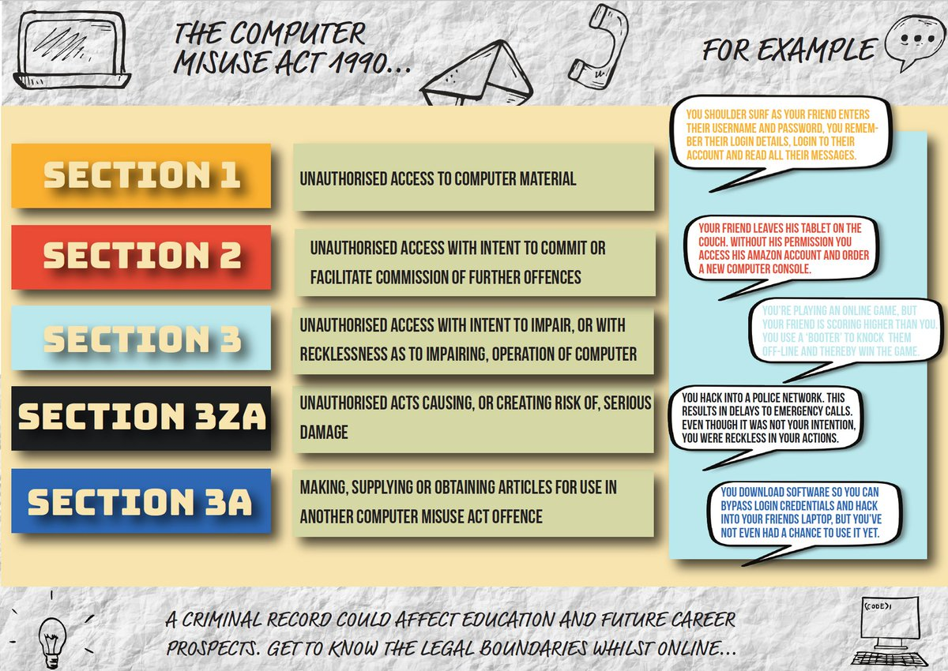
This information can be relayed within our Personal and Online Safety lesson plan, as well as the Sexting Awareness session we can deliver upon request, which will have the appropriate language to suit the key stage level.
Quick Links for Further Information on Cyber Crime:
Computer Misuse Awareness Videos (secondary school level – courtesy of the Yorkshire and Humber Regional Cyber Crime Unit):
https://www.youtube.com/watch?v=QYcKC1OUreg – Computer Misuse – The Suspects Perspective
https://www.youtube.com/watch?v=207aoUZY1nI – Computer Misuse – The Victim Perspective
You can report fraud or cybercrime to Action Fraud any time of the day or night using their online reporting tool. Reporting online is quick and easy. The tool will guide you through simple questions to identify what has happened and our advisors are available twenty-four hours to give you help and advice if you need it.
The Digital Investigations & Intelligence Unit (DIIU) are a team dedicated to tackling cyber dependent crime, providing support and information to staff within Wiltshire Police and the wider public, and providing advice on digital media or cyber in relation to other investigations. For more information on this team, please contact DIIU@wiltshire.pnn.police.uk
For follow up information, please follow our Twitter and Instagram channels (@wiltspolyouth) where we have promoted the safety advice regarding online shopping fraud within the ’12 Frauds of Christmas’ and if you would like to discuss anything raised, please email us on youth@wiltshire.pnn.police.uk or YouthSwindon@wiltshire.pnn.police.uk for more information on how we can support your PSHE sessions.

Educational School Engagement Sessions – Reminder of available lessons for your school / college

The Youth and Early Intervention team have worked with partners to create four educational inputs, available for all schools. These will run alongside any awareness weeks or seasonal messages that may be promoted throughout the school year.

These four core thematic sessions are below:

Session | Overview | Key Stage recommendation* | Learning Outcomes
Primary
People Who Help Us  (approx. 1 hour) | Understanding the role of the police and the concept of 'safe adults'. Promoting friendship and kindness. | KS1 – age 4-6 | • To enable students to understand who their 'safe adults' are  • To allow students to understand the role of the police  • To promote friendship and the importance of being kind
Personal and Online Safety  (approx. 1 hour) | Understanding the dangers of online exploitation and the harm caused by virtual abuse. This training program will look at cybercrime/sexting and how young people can keep themselves safe online. | KS 2 – age 8-11 | • To instil an overall sense of safety in young people  • Educate young people on how to be safe online, exploring topics such as social media and gaming.  • Signpost young people to other support services for help and guidance
Secondary
Sexting and Healthy Relationships  (Approx. 1 hour) | Look at healthy relationships & how to diffuse conflict through restorative practises. Supporting young people to understand coercion & control and what healthy relationships look like. Providing skills to use restorative approaches | KS3 – age 12-13 | • To inform young people on sexting and the law  • To allow young people to distinguish between healthy and unhealthy relationships  • To signpost young people onto services for further support and advice.
Keeping Safe (Exploitation and Vulnerability)  (Approx. 1 hour) | Touching on a range of issues such as County Lines, Weapons Awareness and Criminal Exploitation. This training package will look to identify what makes young people vulnerable/how they can protect and support themselves and each other. Teaching inclusion, diversity & acceptance, to raise awareness of radicalisation and Prevent agenda. The training will signpost to other useful websites or resources, including how to report any concerns. | KS3/4 – age 14-15 | • To inform young people about contemporary issues such as County and Local lines  • To allow young people to recognise the signs of exploitation  • To give young people skills to protect themselves from exploitation
Each lesson plan has:
- A comprehensive crib sheet and PowerPoint, so could be delivered by a Teacher/Pastoral or PHSE Lead, until schools are happy with visitors on site
- Resources for the children to complete and use during the session
- A letter to parents advising of the input, and where they can get further information on the issue being discussed
- An evaluation for the presenter and teacher to complete
- An agreement for the School and Wiltshire Police to sign
- Been reviewed against PHSE criteria
- Been shared with a Speech and Language therapist
* recommended age – however, locally this may be amended for the most appropriate age group, on discussion with the Youth and Early Intervention team and the Head Teacher.
We also have available a Substance Misuse session, and a more targeted Weapon Awareness session, which are not offered as part of the core school engagement offer. These are recommended for secondary schools.

These can be available on request – please email us for more information.

Working with schools during the COVID-19 pandemic

During COVID-19 restrictions, we have been working to review our programmes and are excited to share these with you. We understand with the guidelines, it may not be possible for schools to have visitors on the premises, but we are keen to continue working with you, offering our support and engaging with the children, young people, parents and carers you work with.
If you would any more information regarding the school engagement sessions, or have any further feedback, please do not hesitate to contact your local point of contact, or email us on youth@wiltshire.pnn.police.uk or YouthSwindon@wiltshire.pnn.police.uk

