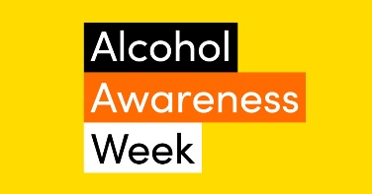
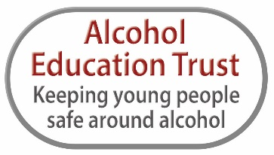
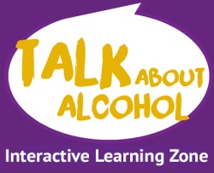

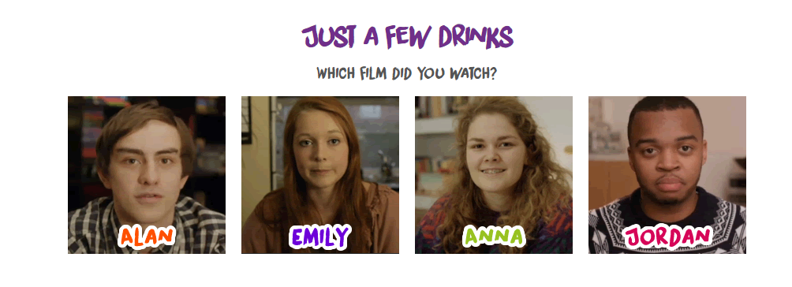
15th – 21st November 2021
https://www.talkaboutalcohol.com/just-a-few-drinks/
Accident/ Injury – Alan’s Story
Lesson plan: https://alcoholeducationtrust.org/wp-content/uploads/2014/11/Alan-LPI.pdf
Friendships – Anna’s Story
Lesson Plan: https://alcoholeducationtrust.org/wp-content/uploads/2014/11/Anna-LPI.pdf
Alcohol Poisoning – Jordan’s Story
Lesson Plan: https://alcoholeducationtrust.org/wp-content/uploads/2014/11/Jordan-LPI1.pdf
Vulnerability – Emily’s Story
Lesson Plan: https://alcoholeducationtrust.org/wp-content/uploads/2014/11/Emily-LPI.pdf

Interactive Learning Zone: https://www.talkaboutalcohol.com/
Website: https://alcoholeducationtrust.org/

