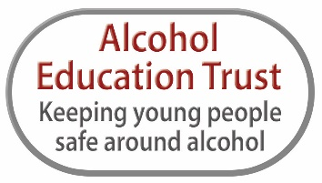
Fully Funded Resources and Training to Help Keep SEN Young People Safe Around Alcohol
The Alcohol Educational Trust has developed comprehensive teaching resources for young people with Special Educational Needs. Working in partnership with SEN specialists - Image in Action - and based on visual rich and story led activities, our SEN Talk About Alcohol Workbook and Guidance can be downloaded here https://alcoholeducationtrust.org/picture_and_story_led_activities/
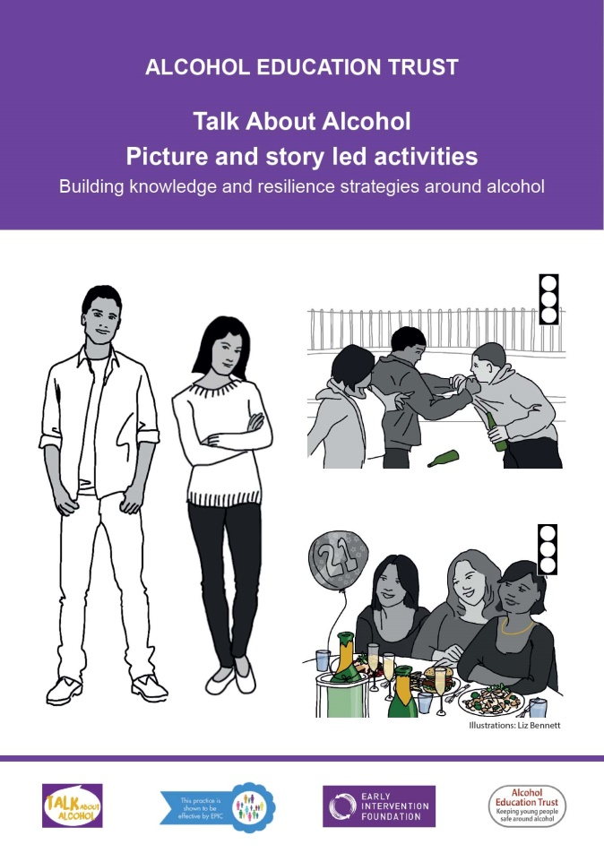
Containing four lessons, each of which are supported by a simple Powerpoint presentation, key aspects of alcohol education are covered: Building Knowledge, Exploring Feelings and Emotions and Consent. Each lesson contains clear aims (including the delay of alcohol use and developing harm reduction strategies), together with details of any additional materials that might be required.
Most of the resources used in the picture and story led lesson plans are included in our Talk About Alcohol Games and Activities Pack. These are particularly suitable for teaching in SEN settings and in many cases, due to generous funding, we are able to support settings with high numbers of children with additional learning needs with a free pack (value £90). All of our resources can be backed by training which is also fully funded. Please contact us if you would like to receive a pack karen@alcoholeducationtrust.org.

“The resources are extremely useful, they give us up-to-date accurate information and excellent ideas in a clear format. Thank you so much. Your hard work will enable us to have a positive impact on our young peoples’ lives.” New Bridge School, Oldham

