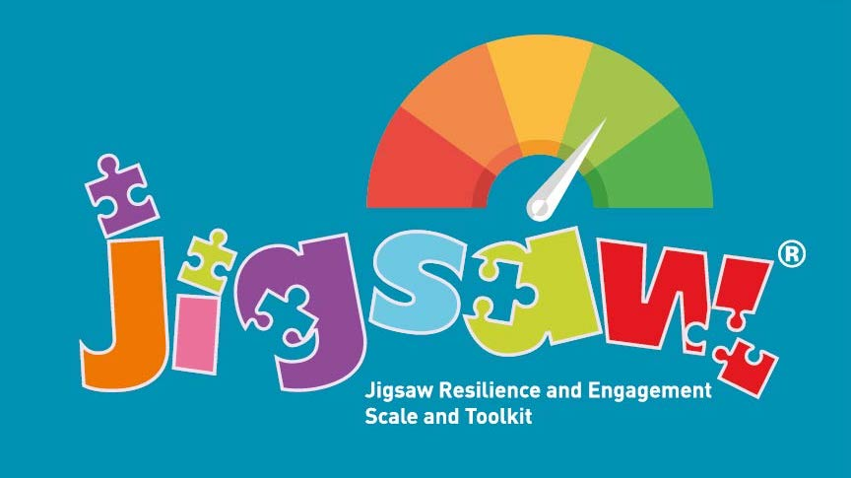

Introducing the Wiltshire Jigsaw Resilience Project
Autumn Term 2022 – end of Spring Term 2023

An opportunity for up to 20 Wiltshire Primary schools (whether already using the Jigsaw PSHE 3-11 Programme or not) to try the Jigsaw Resilience Programme for FREE from the Autumn Term 2022 to the end of Spring Term 2023

Jigsaw will give you:
- Access to the Jigsaw Resilience Programme through the Jigsaw portal, ready to use from Autumn 1 through to the of Spring Term 2 (31st March 2023)
- Training for the Jigsaw Resilience leads to run the Programme
- Ongoing support, mentoring and network meetings led by experienced Jigsaw Resilience Consultant: Carol Catton
- Carol ‘s ongoing support as your Jigsaw Resilience Mentor

What we ask in return:
- The Jigsaw Resilience lead completes the attached SLA and returns it to Carol (carol.catton@janlevergroup.com) by Friday, 16th September 2022
- Carol will confirm your place on the project the week beginning the 19th September

- Jigsaw PSHE 3-11 updates
Date: Monday 19th September 2022 4-5pm on Zoom
Link: https://janlevergroup.zoom.us/meeting/register/tZElde-upjkvGtCiYGUDU3NETrzOzPX6ApE6

- You attend the ‘Introduction to Jigsaw Resilience’ training session for the Jigsaw Resilience leads.
Date: Wednesday, 28th September 3-45pm on Zoom
Link: https://janlevergroup.zoom.us/meeting/register/tZwuceCoqTwqHtPQbrPWJLoOVwMOxQ_1FMzA

(After the training, Rebecca will issue you with your school Jigsaw login to the portal version of Jigsaw Resilience Programme Login expires end of Spring Term 2023, 31st March.)
- You implement the Jigsaw Resilience Programme as written during the pilot project: September 2022 to the end of Spring Term 2023

- You attend the How’s it going?’ network session.
Date: Monday, 21st November 2022 3-3.45 on Zoom
Link:https://janlevergroup.zoom.us/meeting/register/tZcqcemgpzotEtIBNzPW_eLqlcQpCyj2k-44

- You attend the ‘How is it going?’ network meeting
Date: Monday, 16th January 2023 3-3.45pm on Zoom
Link: https://janlevergroup.zoom.us/meeting/register/tZIocemhrzgoHtaI0e17LGhY7kz4H9xe-lqX

- You attend the end of project feedback and next steps meeting
Date: Monday, 13th March 2023 3-3.45pm on Zoom
Link: https://janlevergroup.zoom.us/meeting/register/tZIlf-yhqz4pE9TXn6Kkp9ELQA7V42tpvBwf

The project will be led by Senior Jigsaw Consultant: Carol Catton, with Rebecca Guyett, your contact at Jigsaw HQ for all things admin (office@janlevergroup.com) and in liaison with Jan Lever MBE (Creator and CEO of Jigsaw)

We look forward to working with you as you see Jigsaw Resilience Programme improving mental health, emotional literacy and self-regulation.

For more information about the Wiltshire Jigsaw Resilience pilot project, please feel welcome to contact:
carol.catton@janlevergroup.com

We look forward to working with you

Jan Lever MBE (services to education and children’s mental health)
CEO Jigsaw Education Group

Jigsaw Resilience 2022 Pilot Project
Service Level Agreement

Confirmation of your place within 2022 pilot project will follow on receipt of the completed SLA below.

- Please return your completed SLA to carol.catton@janlevergroup.com
By Friday, 9th September 2022

For more information and assistance, email Carol

Service Level Agreement
- I agree to participate in the Jigsaw Families 2022-2023 project and to the terms and conditions set out in the briefing document above.

School name, address and postcode
Name of headteacher

Heateacher…please confirm your school wishes to participate in the Jigsaw Resilience Project by deleting the appropriate statement | - I confirm I wish my school to participate in the Summer 2022 Jigsaw Resilience Pilot Project, Autumn Term 2022 to end of Spring Term 2023  - I do not wish my school to participate in the Jigsaw Resilience Pilot Project, Autumn Term 2022 to end of Spring Term 2023
Date returned

Our Jigsaw Resilience champion who will lead this project is
Jigsaw Resilience Champion’s role in the school/setting
Contact details for Jigsaw Resilience Champion
(e-mail and telephone number)
Jigsaw PSHE Ltd agrees to the terms and conditions set out above.

