Standard School Asthma Emergency Kit
Contents Checklist:

 | Yes | No | Batch number (if relevant) | Expiry Date (if relevant)
Salbutamol Metered Dose Inhaler (& manufacturers information)
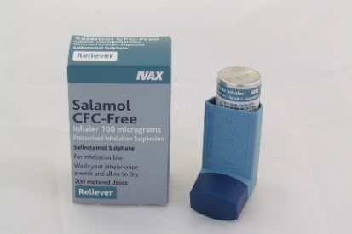
Spacer Device* – Yellow Aerochamber with facemask (under 5’s)
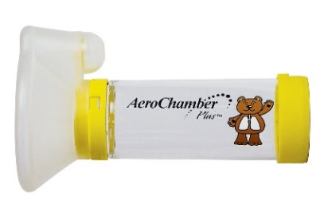
Spacer Device* – Blue Aerochamber (5 and over)
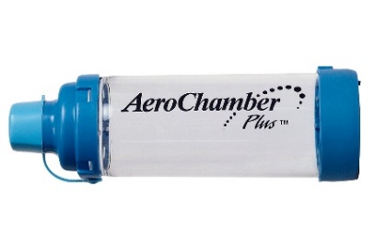
Spacer Device* – Volumatic (with mask if under 5)
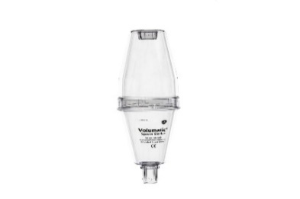
Instructions for:
- How to administer inhaler/inhaler technique
- Cleaning and storing inhaler/spacer
*At least 2 of each single-use spacer devices should be available for emergency use

