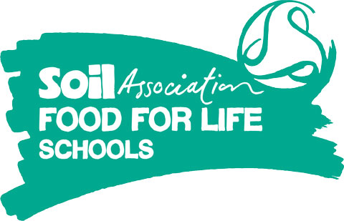
Training Event Booking Form - Wiltshire (3) MDSA training.
Name and address of school:
Is your school enrolled with Food for Life? [ ] Yes [ ] No (visit the Food for Life website to enrol)
Course | Attendee name  and job role | Email address (preferably a direct email to make sure course details reach attendee) | Telephone  number | Dietary/access requirements
MDSA training (session 1)*
05.05.16
Frogwell Primary School, Derriads Lane, Chippenham
Wiltshire. SN14 0DG
MDSA training (session 2)*
06.05.16
Frogwell Primary School, Derriads Lane, Chippenham
Wiltshire. SN14 0DG
There is no charge for training; however, non-attendance or cancellation less than 48 hours before the event may incur a £50 administration fee.
Places are limited to one attendee per school, although we can place a second person on a reserve list in case we have any spare capacity.
To confirm your place, please complete and email this form to fflevents@soilassociation.org. Any queries, please call 0117 314 5180.
Signed: Dated:

